SVQ Research Project
Summary
Phase two of the SVQ research project was a consultation survey exploring areas of interest identified from phase one focus groups. The areas of interest are as follows, which will also be the order in which the paper will discuss them. For an overview of key themes by areas of interest, please refer to the appendix.
- Relationship between NOS and SVQ units
- Inclusion of units not based on NOS within an SVQ
- Removal of End-Tests
- Structure of SVQs
- Promotion of Individual SVQ Units
- Inclusion of meta skills within SVQs
Within these six areas of interest certain themes came up consistently. They are flexibility, consistency of standards, duplication of assessment, and holistic assessment. The theme which arose most often was the connection between flexibility and the consistency of standards of SVQs. Generally speaking, respondents felt the increase in flexibility brought with it a risk of inconsistent standards in the SVQ between different bodies providing them. Thus, the key would be to minimise any loss of consistency in standards while maximising flexibility. Duplication of assessment was mostly in relation to discussions regarding end-tests and their potential removal, while holistic assessment was most relevant when meta skills were discussed. Respondents indicated that end tests were crucial in safety critical sectors, however these sectors account for a small minority of SVQ uptake. The consensus was that end tests should be scrapped as they are not seen as necessary and duplicate assessment.
Overall, responses did not indicate a one size fits all approach and in fact there were numerous comments where respondents stated a nuanced approach making changes in the SVQs would be the best. For example, sometimes duplication of assessment is crucial especially when discussing safety relevant qualifications where it is crucial to have working knowledge of procedures and protocols as they have very real consequences worker wellbeing.
The breakdown of respondent types can be found below. 33/57 respondents were either a training provider, awarding body, or college. These organisation types were heavily involved in phase one and are largely responsible for the provision of SVQs.
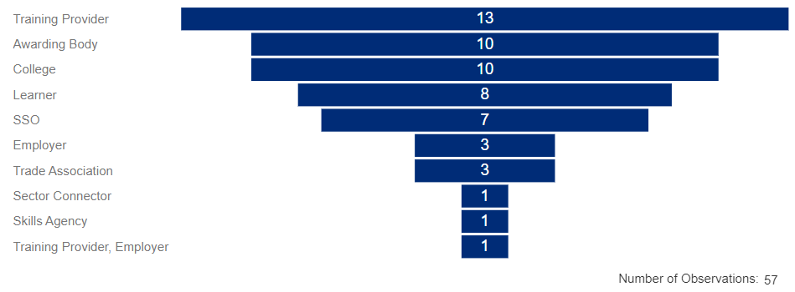

Results and Discussion by Area of Interest
Relationship between NOS and SVQ units
Q4: Moving to a system where the one-to-one relationship between a NOS and an SVQ unit is removed would create more flexibility.
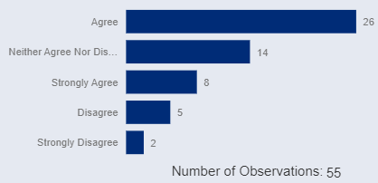
Q5: Moving to a system where the one-to-one relationship between a NOS and an SVQ unit is removed would benefit employers.

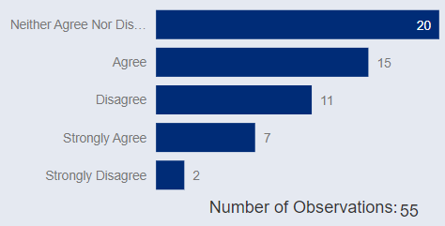
Q6: Moving to a system where the one-to-one relationship between a NOS and an SVQ unit is removed would benefit learners.

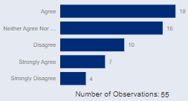

Overall, there was agreement that the removal of the one-to-one relationship would create flexibility with 34/55 either agreeing or strongly agreeing this is the case. The large proportion of neither agree nor disagree responses gave an indication that respondents felt there was nuance to the situation. When asked if the move would benefit employers 22/55 agreed or strongly agreed compared to 13/22 who either disagreed or strongly disagreed. 25/55 agreed or strongly agreed the move would benefit learners with 14/55 disagreeing or strongly disagreeing. Thus, respondents did feel that removing the one-to-one relationship with NOS would increase flexibility. However, respondents were not as clearly positive about whether moving to a system where the one-to-one relationship is removed would benefit employers and learners. Although there was generally a larger proportion of individuals who agreed or strongly agreed the move would benefit employers and learners there is no clear consensus. Thus, the topic requires further discussion to tease out if the additional flexibility from removing the one-to-one relationship between NOS and SVQs would be beneficial.
Themes from Comments
When observing the comments from the section, some of the themes which stood out were “flexibility”, “awarding bodies” (ABs), “Standard”, “change”,” units”, “skill”, “review”, and “develop”. Respondents generally saw the changes impacting NOS reviews, potential differing standards in qualifications between ABs due to increased flexibility, and how the changes to the one-to-one relationship could influence matching skills taught to what the labour market demands. The view based on the comments is nuanced and the proposed change from a one-to-one relationship with NOS and SVQs is not in itself good or bad. For example, there is a concern that the removal of the one-to-one relationship would dilute standards and impact consistency between awarding bodies.
“Whilst that offers flexibility, appropriate assessment is key to avoiding a dilution of the standard and consistency in the achieved skill.”
Awarding body respondents shared this concern over differing standards between awarding bodies due to the removal of the one-to-one relationship. The positives of removing the one-to-one relationship according to respondents was a more flexible approach to qualifications where the qualifications could react to employer requirements.
“This can only be a positive move - it will enable greater flexibility of awards and allow them to be more representative of employer requirements.”
This was mirrored in other similar comments where the general consensus was that the increased flexibility as the one-to-one relationship would be removed would allow for qualifications to react to changes in the skills demanded by the labour market. This would benefit learners as they would receive qualifications with in-demand skills while employers could quickly plug existing skills gaps. Respondents who did not agree that the removal of the one-to-one relationship would be beneficial to learners and employers felt that the consistency of standards which coupling SVQs to NOS provides is valuable and there are other options to increase flexibility, such as, more regular NOS reviews or the ability to make small tweaks flexibly.
“SVQs should be aligned to NOS to ensure consistency of practice and to maintain professional standards… There should be more emphasis on Sector Skills bodies having a regular review schedule for the NOS for which they are responsible.”
“…If NOS is written correctly changes can be tweaked within the SVQ allowing for changes to be made to ensure the program is kept up to date and allow for improvements within framework documents.”
In general, the positives of NOS were seen to be the consistency of standards in the same qualification between awarding bodies, but this was seen to decrease flexibility, problematic in industries with a fast pace of change. However, there were concerns with the lack of consistency which may result from removing the one-to-one relationship between NOS and SVQs. Even respondents who agreed that the relationship should be removed did concede that it would need to be done correctly and an effort made to keep standards consistent across awarding bodies.

Inclusion of units not based on NOS within an SVQ
Q9: The inclusion of units not based on NOS in an SVQ would increase flexibility.
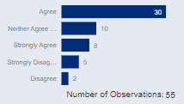
Q10: The inclusion of units not based on NOS in an SVQ would benefit employers.

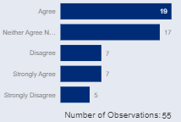

Q11: The inclusion of units not based on NOS in an SVQ would benefit learners.

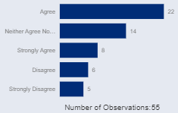

Q12: If this change goes ahead, there should be a requirement that the majority of units included in an SVQ are SVQ units.

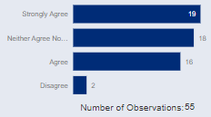
Respondents agreed that including units not based on NOS into SVQs would increase flexibility with 38/55 either agreeing or strongly agreeing while 7/55 disagreed or strongly disagreed. There was strong agreement that a majority of the units in SVQs should be based on NOS as 35/55 agreed or strongly agreed while only 2/55 disagreed or strongly agreed. 26/55 agreed or strongly adding units not based on NOS to SVQs would benefit learners and 30/55 agreed or strongly agreed it would benefit employers. This is compared to 12/55 and 11/55 disagreeing or strongly disagreeing, respectively. These results in combination with results from the first section indicated removing the one-to-one relationship with NOS and using units not based on SVQs would both increase flexibility according to respondents. This confirms sentiment in phase 1 of the research where respondents indicated removing the one-to-one relationship with NOS and using units not based on SVQs could be avenues for increased flexibility within SVQs. However, as will become clear the flexibility would not come without its own challenges and the question is whether the increased flexibility from both options would outweigh the costs and whether there is an alternative route to increase flexibility.
Themes From the Comments
Although there was general agreement that non-SVQ units would bring flexibility, the loss of standardisation and credibility of the SVQs brand due to the inclusion of non-SVQs was a large concern for respondents who felt that non-SVQ units should not be included.
“I would not like to see additional units brought into the SVQ that were not based on NOS as this process at present is robust and gives all stakeholders input carried out through Industry bodies... This (inclusion of non-SVQ units) may be difficult to manage for some sectors as disseminating information of changes may be difficult.”
Respondents who agreed or strongly agreed that non-SVQ units could be included in SVQs generally appreciated the flexibility it would bring into the system. The need for flexibility did come with a clear preference or even requirement to keep a majority of the units competence based, even if the majority of the units weren’t necessarily SVQ units.
“If not managed correctly, there is a risk that the proposed change could impact the balance between competency and knowledge, and lead to SVQs that are less competency based than at present. There is also the risk of a dramatic increase in the number and size of units included in SVQs by Awarding Bodies. This outcome will be avoided by putting in place rules to ensure that SVQs remain predominantly competency based.”
Assessment, flexibility, and transferability are closely linked when discussing SVQs and potential changes to the SVQ system. Competence-based and knowledge-based qualification would be assessed very differently, end tests for example, are common in knowledge-based qualifications. Some respondents felt that assessment was an area where flexibility could be brought into the SVQ system and that non-SVQs could be a part of this approach.
“Whilst NOS and the subsequent SVQ units are based on Skills and Knowledge to achieve competence, there would be value in understanding how experience and behaviour can be assessed as part of an SVQ. Perhaps these can be non-NOS measures or requirements.”
In contrast, some respondents felt that flexibility could be brought into the SVQ system itself by changing requirements for SVQs rather than bringing in non-SVQ units into SVQ qualifications.
“Would it be worth reviewing the requirements of an SVQ unit, to see if its definition can become more flexible?”
Generally, there was a positive response to the addition of non-SVQ units but the respondents felt it was crucial to maintain the SVQ brand and avoid large inconsistencies within the system. The number and size of units between awarding bodies was a concern, for example, as this could make the SVQs incomprehensible for employers. Making it difficult to maintain consistency within SVQs, and thus transferability, which both of which respondents felt were to be maintained as they were key strengths of SVQs.
Removal of End-Tests
Q15: End tests duplicate assessment already undertaken in an SVQ.

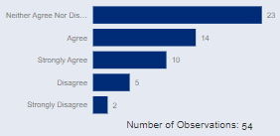

Q16: The inclusion of end tests in SVQs are beneficial to employers.

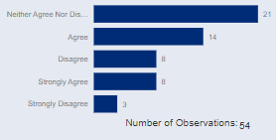

Q17: The inclusion of end tests in SVQs are beneficial to learners.

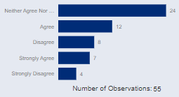
The most common response when participants were asked about end tests was “neither agree nor disagree” which would indicate that many respondents may not have been able to give a clear answer to the questions. This could be because the questions may have been more relevant to practitioners in the system than, for example learners or employers, as they may not have as much involvement in the practical assessment side of SVQs. 24/54 respondents agreed or strongly agreed that end tests duplicate assessment, while 7 agreed or strongly disagreed, however 23 respondents responded “neither agree nor disagree”, thus although there is some agreement there is no definitive position adopted by respondents. 22/54 and 21/55 respondents agreed or strongly agreed while 11/54 and 12/55 disagreed or strongly disagreed that the inclusion of end-tests would benefit learners and employers respectively. Thus, there were more than three times the number of respondents who felt that end-tests duplicated assessment. Almost twice the number of respondents felt end-tests benefitted learners and employers compared respondents who stated that end-tests didn’t benefit learners or employers. However, it should be highlighted that the most common response for all three questions was “neither agree not disagree” and there was no definitive majority when asked if end tests would be beneficial for learners and employers, indicating a lack of clear consensus.
Themes From the Comments
Respondents who strongly agreed with the statement that end tests duplicate assessment tended to state that end-tests were either unnecessary or did not serve the purpose of proving competence. In other cases, respondents felt that the use of end tests should be limited and restricted to qualifications which underpin a licence to practice. A similar sentiment was forwarded by respondent who disagreed with the statement that end-tests duplicate learning.
“We would support the complete removal of end-tests. It is best practice only to test competent performance and knowledge application once, and end-tests generally duplicate testing performed during the qualification. Working with training provider professionals, employers are best placed to judge when a learner is competent in the workplace setting.”
“In the very limited situations where the qualification underpins a license to practice product, consideration could be given to retaining end-tests. However, the circumstances requiring this should be minimal, and end-tests should be retained only were absolutely necessary.”
Respondents indicated the end-tests served an important purpose in proving competence especially in safety critical industries where end-tests are used to ensure consistent level of competence. They also indicated that the duplication that may appear is assessment due to end-tests was deliberate and necessary. This is where there are important differences in the respondents as duplication is not necessarily a negative aspect for all respondents and in some sectors it may be needed or even necessary.
“The holistic aspect means that all they have done to date is assessed. This inevitably includes duplication but that is both deliberate and necessary in a safety-critical industry. Note that ’time-served’ is no indication of competence whereas the end-test ensures a consistent level of competence.”
The views of the respondents who responded, neither agree nor disagree, were quite nuanced. In some cases SVQs were compared to vocational qualifications outside of Scotland where end-tests were not necessary to achieve a qualification, with the additional point that there was no clear guidelines for the purpose of the end-tests which can make it difficult to justify to students.
“If a learner achieves all of the SVQ units but not the end/skills tests, they do not achieve their SVQ in Scotland. If they take this evidence to a provider registered anywhere else in the UK, they can achieve their VQ. This seems utterly bizarre that a skills test is needed in Scotland but not anywhere else in the rest of the UK and needs addressed.
There are no guidelines on what the purpose, aim or objective of an end/skills test is. This creates problems in many ways not least for the development and review of skills and end tests. Learners find it difficult to understand the difference between the SVQ and the end-test with regards to competence and training staff find it difficult to explain that difference and purpose.”
It was also clearly situation dependent for these respondents as well since respondents could neither agree nor disagree with the statement that end tests should be dropped but feel as if there was use for them in terms of delivering value to learners and employers.
“The Electrical Installation SVQ has an End Test. We accept that it can involve duplication. However, the end test is a holistic simulation and it is timed - it is therefore more realistic of a work situation. It also indicates retention of knowledge and ability to apply that knowledge and skills. The End Test is independent of the training centres. It is industry led. It is holistic, realistic and robust.”
As it may be clear there is no clear yes or no answer for whether end-tests should be included but there is some indication that the preferences for end-tests are industry specific. Safety critical qualifications or qualifications or qualifications where safety procedures play a key role may benefit from the duplication of end-tests and the proof of recall of knowledge which these industries may require of their employees. However, this is not necessary for all industries and an industry specific approach to end-tests may be a way to avoid duplication of knowledge where it may not be necessary while maintaining the useful and necessary duplications, along with a proof of knowledge, they may bring in safety critical industries.
Structure of SVQs
Q20: The removal of multiple pathways in an SVQ and replacing these with a larger number of optional units would improve flexibility for employers.

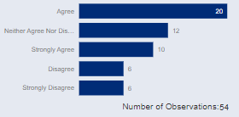
Q21: The removal of multiple pathways in an SVQ and replacing these with a larger number of optional units would improve flexibility for Learners.

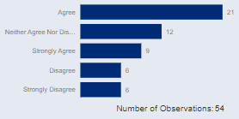
30/54 of respondents stated they agreed or strongly agreed that removing multiple pathways in SVQs and replacing them with optional units would increase flexibility while 12/54 stated they disagreed or strongly disagreed. 30/54 of respondents either agreed or strongly agreed that removing multiple pathways would benefit learners while 12/54 stated they disagreed or strongly disagreed. Thus, respondents felt that the flexibility from the possible removal of pathways, in favour of more optional units, would add flexibility into SVQs which would benefit learners. This is interesting as in previous sections the removal of end-tests may have increased flexibility but this flexibility was not always viewed by the respondent as being beneficial for the learner or employer.
Respondents largely agreed or strongly agreed that multiple pathways could be scrapped in favour of a larger selection of optional units. The respondents had nearly an identical answer to if this would improve flexibility for learners as nearly all who agreed or disagreed with the statement that pathways should be scrapped in favour of more optional units also answered the same to it allowing for flexibility for learners.
Themes From the Comments
Respondents who agreed with the statement that pathways should be replaced with a larger selection of optional units stated that the flexibility would benefit learners and employers. Some respondents felt that small to medium sized enterprises (SME’s) struggle with matching job roles to the frameworks. It also stands to reason this issue may be the case for larger companies as well if the frameworks do not clearly fit the job roles which exist in the company.
“SMEs struggle to match job roles to frameworks (and vice versa). A bigger selection of optional units would be advantageous to employers and learners here.”
Respondents also felt that the increased flexibility from a larger selection of optional units compared to frameworks would increase flexibility and so strengthen the student voice as they would have an impact on how the provider would design the curriculum.
“Increased flexibility would help strengthen the student voice which would have more impact on Curriculum design and delivery”
The increased flexibility does not come without its downsides. Even though getting rid of pathways and introducing a larger selection of optional units would increase flexibility for learners and employers as the flexibility would come with logistical difficulties of providing a wide variety of optional units. The large amount of optional units can also separate what the learner is learning from what the employer demands.
“…There is and can be no ‘one fits all’ approach. There needs to be a careful balance between the number of optional units and their intended purpose in the structure with the requirements of the job. Having too many optional units in a structure separates it from the realities of the job and is not helpful for employers or learners. In addition, often providers cannot deliver the wide range of optional units available in some structures as they need to find occupationally competent assessors to do this…”
Respondents also highlighted that the pathways should not matter and that the qualification title should give all the relevant information for the employer and if employers would rather have certificates which showed more detail of the units it should be taken into account. Of course, respondent views on the subject were varied, however, it does point to how important what is on the certificate is. Comments such as the below, also point to the option of having separate qualifications instead of pathways within the same qualification as they would clearly represent what the student studied to employers.
“If we are looking for a more streamlined system with transferable skills highlighted, it shouldn't matter which pathway is taken, the overall qualification title i.e. 'Construction Site Supervision' should be enough. However, if the employers would rather see the specifics on a certificate, rather than have it hidden within the units, that needs to be taken into account.”
Respondents who disagreed or strongly disagreed stated a few main themes. The possibility of learners with the same qualification but a varied set of skills, potential competence related issues as candidates might choose inappropriate units, and harder to see a clear path to achieve an appropriate set of units for both candidates and employers.
“Pathways are there to reflect the specialism of the apprentice and, hence, the business of the employer. Their removal would leave a pick and mix which could have significant implications for competence and safety if the inappropriate (or ‘easy’) units were selected.”
“pathways are identified during consultation with the sector and give a clear indication for endorsement of the learners achievement. I fail to understand how removing pathways and having a large selection of optional units would benefit employers and make the context of the learners achievement clear.”
There are clear issues which respondents outlined with using optional units instead of pathways but at the same time there would be clear benefits from the flexibility. Based on the comments it seems clear that there may be no clear one size fits all approach and the approach for safety relevant qualifications may need to be more inflexible but deliver consistent competencies. However, in other industries the additional flexibility can be beneficial for candidates and employers if stakeholders are clear on what the candidate has achieved once certified. The additional flexibility may be useful but there would need to be clear limits to it in terms of set achievement requirements so that employers can be confident they know what has been achieved for example.

Promotion of Individual SVQ Units
Q24: The promotion of individual SVQ units or groups of SVQ units, in addition to the promotion of the full SVQ would provide flexibility for employers.
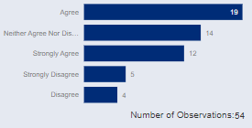
Q25: The promotion of individual SVQ units or groups of SVQ units, in addition to the promotion of the full SVQ would provide flexibility for Learners.
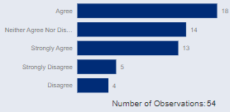
31/54 respondents indicated that they agreed or strongly agreed that promoting SVQ units or groups of SVQ units would provide flexibility for both employers and learners while 9/54 disagreed or strongly disagreed with the statement. Thus respondents largely agreed with the statement that flexibility of the SVQ system for learners and employers would be improved through the utilisation of individual units either on their own or in a group of individual units or a group award.
Similar to the questions on pathways in SVQs the responses to the two questions about promoting individual units received a similar response, respondents who agreed that promoting units would promote flexibility also felt that it would provide flexibility for learners.
Themes From the Comments
There was strong support for promoting individual units and respondents found it can be helpful in contexts such as CPD where units or even groups of units can be taken to support employee development. It was also forwarded as a good way to promote SVQs for employers who may not be using them at the moment as they can dip their toe into SVQs by utilizing units in, for example, their CPD and from there encourage uptake of full SVQ qualifications. As with the issue with pathways any use of units or group awards should be industry led and come from the employers to ensure any use of units will improve candidate labour market relevant competence.
“More cost effective for people to study CPD units and achieve these as an actual qualification rather than unrecognised qualifications.”
“Definitely something that might encourage employers to engage with the SVQ system and would benefit their employees. Hopefully sucess in smaller clusters of units would encourage uptake of full SVQ qualifications.”
“What might be appropriate for one industry/occupation may not be relevant to another. This should be industry led.”
Respondents who disagreed with the statement that units promoted flexibility for employers stated issues with units or group awards taking the place of larger qualifications effectively taking a “light approach” to what a full SVQ qualification would be. This was highlighted as a potential threat to the SVQ brand as if the use of units or group awards were common and conflated with full SVQs. This could hurt the recognition of the qualification as a high quality qualification and thus the transferability of the qualification, especially if candidates who would use the units or qualifications would be seen as underqualified.
“Potential to devalue the term “SVQ” – we need consistent outcomes for competent people against occupational needs.”
“In a world where competency and evidence of this is becoming increasingly required, this would lead to “light” approach to what is considered a qualification. It has the potential to undermine the SQA certification and recognition across the UK and therefore devalue the brand.”
Respondents indicated the promotion and use of units would provide flexibility to SVQs, however the brand may be damaged if the use substituted full qualifications, for example. They also indicated that their use in the correct way could further promote the use of SVQs and add flexibility for SVQs to make further contributions in the market for CPD. The use of units should be well defined in order to protect the brand from over use of units while allowing for flexibility for smaller qualifications. Based on the responses it would not be wise to use units if they were to consistently substitute for a full qualification.

Inclusion of meta skills within SVQs
Q28: Meta skills should be included in SVQs and assessed holistically.
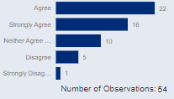
Q29: Including meta skills to the SVQ would benefit employers.
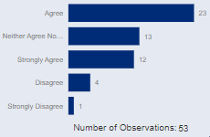

Q30: Including meta skills to the SVQ would benefit learners.
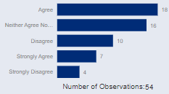
40/54 respondents responded that they either agreed or strongly agreed with the statement that meta skills should be added into SVQs and assessed holistically compared to 6/54 who disagreed or strongly disagreed with the statement. It should be noted that the question had the highest proportion of positive responses along with the fewest neither agree nor disagree responses which indicates a strong preference for meta skills to be incorporated into SVQs. 35/53 respondents stated that the addition of meta skills to SVQs would benefit employers while 5/53 indicated that they disagreed with the statement. 25/54 agreed or strongly agreed that including meta skills would benefit learners while 14/54 disagreed or strongly disagreed with the statement. This indicated that the inclusion of meta skills into SVQs and their holistic assessment would benefit employers and learners although there is stronger consensus that the addition would benefit employers while it is not as strong in terms of any benefit to the learner. This gives an indication that respondents feel the move to include meta skills in SVQs would be more beneficial for the employers than learners.
Themes From the Comments
Respondents who agreed that meta-skills would benefit employers or learners indicated that the alignment between SVQs and competence-based qualifications (CBQs) would be positive. However, the benefit from the use of meta-skills came with caveats. The approach to the use of meta skills would need to be consistent and the use of holistic assessment would need to be clearly understood. As with the previous themes there were caveats to the positive responses given and in this case the use of meta skills would only be helpful if consistency was maintained between qualifications and if assessment was consistent between qualifications.
“…not all learners are apprentices and some individuals will still need a standalone product that is not part of an apprenticeship. If introducing meta skills helps that alignment then that would ensure the products are more comparable.
Closer monitoring of entry requirements would be required to ensure the qualification being undertaken is the right match for their skills/capabilities.”
“The practicalities of holistic assessment need to be understood: for example, how are meta-skills to be assessed on a construction site, and by whom? Assessment needs to be practicable to deliver and this may vary across sectors. This is an area in which we are still learning.
It may also be important that a consistent approach to including meta-skills is devised if they are to be included. At the moment, new model apprenticeships take one of 2 approaches – offering a separate unit,or including across units. This may be confusing for those delivering.”
“Training Providers have been calling for core skills to be mapped across technical qualifications for years. Core Skills, although vital, can be assessed in multiple ways and not all learners have the same approach to learning or assessment. Meta skills will provide the core skills evidence but in an applied way that might better suit some learners.”
Respondents who responded “neither agree nor disagree” indicated that adding meta skills would only cause confusion for learners and employers as they do not use these terms.
“Employers want their employees to develop appropriate skills and qualities so my concern is badging something as meta skills only adds to confusion with employers and learners.
Meta skills/core skills/essential skills; no employer uses these terms. Instead they consistently advertise jobs looking for candidates with particular ‘Skills and Qualities’.”
Respondents who disagreed or strongly disagreed with meta skill benefitting learners and employers felt that there would need to be a clear communication between stakeholders involved in the meta skills process. Respondents were also sceptical about the benefits of meta skills as it was seen as something which employers might not even appreciate as it was not going to show up on a CV.
“SDS and SQA need to work together more effectively. To have more holistic assessment against SVQs / quals needs to be streamlined. They need to decide what is most relevant and have that included in an apprenticeship. I don’t know what ticking off some meta skills adds to the learner, they will obviously have this through doing an apprenticeship, it just adds a few more things, that they won’t put on a CV or application.”
There was a strong consensus that meta skills would benefit learners and employers. It should be mentioned that the criticism of meta skills not showing up on a CV is something worth considering when considering meta skills. It may be useful to make it clear to candidates that the meta skills can be a proof of competence in soft skills which employers value highly. However, due to meta skills being new as a concept it has not been clearly defined. In addition, they have not been embedded into qualifications at a scale at which it is possible to make a clear comment on their effectiveness. Thus, it would be prudent to defer any judgements on meta skills to a time when it is clearer as a concept and there is evidence of them being embedded into qualifications at a larger scale.
Respondents Closing Comments
Respondents were asked to add additional comments and in these additional comments they emphasise the importance of themes, such as holistic assessment, assessment burden, the importance of funding models in the system, and flexibility of SVQs. Respondents indicated a holistic approach to assessment could decrease assessment burden and make the completion of portfolios and assessment requirements easier for learners and providers.
“Encouraging providers to, where possible, take an holistic approach to assessment, rather than a Unit by Unit approach, as highlighted in an earlier response. This approach should reduce assessment burden on learners and allow them to understand how the different components of their SVQ fit together and support one another in the context of their job role and the organisation in which they work.
Work-based learning, should not carry an assessment burden for candidates, but allow them to show, as naturally as they can, what they have learned and the skills they have developed which allow them to (more) effectively carry out their job.”
Funding models were a clear theme in phase one of the research project and mentioned in the additional comments. The respondent highlighted how in some cases the cost of delivery is not covered by the available funding. In phase one respondents also noted that the funding model for apprenticeships was inflexible and that funding was driving development and usage of SVQs rather than the market. These point to funding being a crucial issue to consider when considering improvements to the SVQ system.
“A simplification of milestones funding model for MAs by SDS, would aid delivery of SVQs
There is an opportunity to review the funding provided for the delivery of an SVQ, as in many cases this can be inadequate to cover the actual delivery and some financial modelling could be undertaken to ensure financial sustainability.”
Better guidance and support along with system wide clarity were also highlighted in the final comments, themes which came up often in phase one of the research project. Respondents felt that there was a need to reduce complexity within the SVQ system in order to make it easier to interact with.
“Portfolio completion and assessment requirements can be quite challenging for learners/colleges so a simplified and common sense approach is needed to reduce the complexity. Any changes to SVQ content/elements/requirements should be mindful of the capability of the delivery network to meet those requirements. Better guidance and support can also come from the awarding bodies.”
Overall, in phase one respondents were positive about the potential for SVQs to deliver value in the education system and respondents echoed this sentiment in phase two as well with respondents stating that it can play an important role in upskilling and reskilling the workforce.
“We support greater flexibility within the SVQ product to better underpin and support learners’ skills and knowledge and align with the skills needs of employers. There is an important role for enhanced use of the SVQ product for upskilling and reskilling.”
Concluding Considerations
Flexibility was the most common theme which arose throughout the project, but there were caveats associated with flexibility. For example, the SVQs generally would benefit from flexibility but when adding flexibility to the system consistency of the qualification would need to remain high. This is true for any possible differences between awarding bodies and between different providers working with an awarding body. Consistency and transferability where important to respondents and they were generally seen as strengths of the SVQ brand.
An important theme which came across multiple areas of interest was clarity. There needs to be clarity around, for example, what are meta skills or what can be classed as an SVQ and what might be a CBQ. This need for clarity extends to assessment, as mentioned above and based on responses SVQs could be improved by improving clarity around assessment. Clearer guidance around assessment could be a way to improve clarity within the system.

Appendix
Overview of Sections and Issues, Positives, and Conclusions within the sections.
Sections | Themes | Issues | Positives | Conclusion
Relationship between NOS and SVQ units | (flexibility v. comparability) | Loss of Transferability  Inflexibility  Inconsistencies between AB’s and providers | More representative of employer requirements | Flexibility only worth it if SVQs remain transferrable.  More frequent NOS reviews.
Inclusion of units not based on NOS within an SVQ | (flexibility, SVQ unit threshold) | Loss of Transferability  Inconsistency between ABs  Possibly incomprehensible to employers | Increased Flexibility | Increased flexibility from non-SVQ units while maintaining the SVQ Brand.  Majority must be SVQ units.  Likely changes must remain peripheral to control inconsistencies between ABs and keeping it comprehensible for casual stakeholders while adding flexibility.
Removal of End-Tests | (Duplication of proving competence) | Duplication  How to assure competence | Good to duplicate learning in safety relevant industries | Keep end-tests in safety critical industries where proving competence and repetition are both important.
/Structure of SVQs | (Pathways  , promoting units) | Inconsistency between ABs  Possibly incomprehensible to employers | Matching jobs to what is being taught (pathway inflexible) | Flexibility would be beneficial but it could make it difficult for employers (even learners) to know if learner is competent for job role.
Promotion of Individual SVQ Units | (Flexibility) | brand may be damaged if the use substituted full qualifications | Helpful for CPD within an organisation where a full qualification may not be necessary.  Additional flexibility | Flexibility would be beneficial but it could make it difficult for employers (even learners) to know if learner is competent for job role.
Inclusion of meta skills within SVQs | (Holistic assessment) | Meta skills process is unclear, the definition of holistic assessment is unclear  Sceptical of their benefit. | Proof of soft skills  If done right holistic assessment could reduce assessment burden. | Respondents felt meta skills would be beneficial if holistic assessment could be done consistently

