
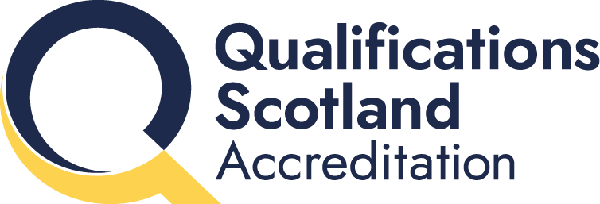

Annual Statistics Report
Report on accredited qualifications
1 April 2025 – 31 March 2026

August 2026
Assuring Quality

Contents
Introduction from the Convenor of the Accreditation Committee 1
Summary 1
1 Introduction 2
1.1 About Qualifications Scotland Accreditation 2
1.2 Governance and accountability 3
2 Annual statistics 4
2.1 Accredited qualifications 4
2.2 Top 5 registrations and certifications 5
2.3 Analysis by qualification type 6
2.4 Analysis by SCQF level 7
2.5 Analysis by awarding body 9
2.6 Analysis by qualification category 11
2.7 Analysis by qualifications developer 13
2.8 Workplace Core Skills 14
3 Operational activity 2025–26 15
3.1 Standards and Frameworks commissioning 15
4 Project groups 17
4.1 Stakeholder Engagement and Communication Strategies Project Group 17
4.2 Fast track approval of awarding bodies 17
4.3 Assessment Arrangements Research 18
4.4 Emerging technologies 18
5 Regulatory Activity 2025–26 18
5.1 Awarding bodies 20
5.2 Themes of Issues and Recommendations raised 22
6 Chief Accreditation Officer: A look ahead to 2026-27 25
Appendix: Qualifications Scotland Accreditation approved awarding bodies 27

Introduction from the Convenor of the Accreditation Committee
I am pleased to introduce this Annual Report for Qualifications Scotland Accreditation, covering the period from 1 April 2025 to 31 March 2026.
This has been an important year as we continue to establish Qualifications Scotland under the Education (Scotland) Act 2025. The Act sets out Qualifications Scotland Accreditation's independent statutory role in accrediting qualifications and regulating awarding bodies. The Accreditation Committee provides governance and oversight of these functions on behalf of Scottish Ministers, helping to ensure that our decisions are independent, evidence-based and always focused on protecting learners and maintaining public confidence in Scotland's qualifications.
This report highlights the wide range of work carried out over the past year. Alongside the statistics on accredited qualifications, it shows how we approve and monitor awarding bodies, oversee the quality of qualifications, support the development of National Occupational Standards, and help ensure that accredited qualifications continue to meet the needs of learners, employers and Scotland's economy.
Although accreditation is required for some qualifications, many organisations also choose to have their qualifications accredited because it provides an independent mark of quality and assurance. We are proud to support a regulatory system that is proportionate, trusted and respected by learners, employers and awarding bodies alike.
The Committee has continued to provide support, challenge and strategic oversight throughout a year of significant change. We have worked closely with the Chief Accreditation Officer and the Accreditation team to ensure that our regulatory responsibilities continue to be delivered effectively while also looking ahead to future improvements.
I would like to thank everyone in Qualifications Scotland Accreditation for their professionalism, expertise and commitment over the past year. The team's dedication, particularly during a period of organisational change, has ensured that we continue to deliver a high-quality regulatory service and maintain confidence in Scotland's accredited qualifications.
I would also like to thank my fellow Committee members for the knowledge, experience and commitment they bring to our work. Their independent perspectives and thoughtful challenge are essential to good governance and help ensure that the Committee continues to provide effective oversight.
As we look ahead, we remain committed to working collaboratively with awarding bodies, employers, government and other partners to support continuous improvement while maintaining high standards and public confidence in accredited qualifications.
I hope this report provides a useful overview of our work and demonstrates the important contribution that Qualifications Scotland Accreditation makes to Scotland's education, skills and qualifications system.

Dr Ken Thomson OBE DL
Convenor of Accreditation Committee

Summary

Activity | Total
Provider monitoring visits performed and reports published | 36
Awarding body audits carried out | 10
Candidate registrations across all accredited qualifications | 138,578
Candidate certifications across all accredited qualifications | 117,101
New awarding bodies received approval by Qualifications Scotland Accreditation | 1
Awarding bodies in total approved by Qualifications Scotland Accreditation | 34

1 Introduction

1.1 About Qualifications Scotland Accreditation
As well as a central corporate function, Qualifications Scotland has two distinct and autonomous parts:
- Qualifications Scotland Awarding
- Qualifications Scotland Accreditation
The Education (Scotland) Act 2025 (“the Act”) sets out that Qualifications Scotland Accreditation has the function of:
- accrediting qualifications as meeting such requirements as are specified by it, and
- making appropriate arrangements to determine the suitability of the establishments which provide, or are to provide the above accredited qualifications
Our main activities in carrying out these functions are:
- Approving awarding bodies (organisations that award qualifications) to deliver a wide range of qualifications in Scotland.
- Working with standard-setting organisations to develop and maintain National Occupational Standards (NOS) for vocational qualifications such as SVQs – to define the knowledge, skills and understanding people need to do specific jobs
- Quality assuring and approving Scottish qualification structures and associated qualification products
- Accrediting qualifications – including SVQs and other work-based qualifications.
- Auditing and monitoring approved awarding bodies and their delivery partners, (such as colleges and private training providers) to ensure they continue to meet regulatory requirements.
- Formally assessing and approving Scottish Credit and Qualifications Framework (SCQF) levels and points for qualifications.
Qualifications Scotland Accreditation also plays a central role in advising and supporting standards setting organisations (SSOs) in the development and review of National Occupational Standards (NOS), and with qualification development. We are responsible for approving and quality assuring NOS and qualification products including qualification structures, assessment strategies and Core Skills signposting.
We are also an approved Scottish Credit and Qualifications Framework (SCQF) credit rating body and are the only body with the authority to credit rate SVQs.

1.2 Governance and accountability
Qualifications Scotland Accreditation consistently aims to work efficiently and effectively to best deliver on our responsibilities. Our work is underpinned by a set of Regulatory Principles, Regulatory Principles Directives and the Accreditation Licence.
Our work is overseen by the Accreditation Committee, which reports directly to Ministers. It reports to, but is independent of the Qualifications Scotland Board, and is comprised of individuals from industry, skills bodies, and of course the Accreditation Committee Convenor and our Chief Accreditation Officer.
The unit has its own Corporate Plan, which in turn informs our Operational Plan. All our Operational activities are driven by this plan, as well as the responsive nature of the team. Our aim is to continually review and improve processes and systems for the benefit of all external and internal customers.
This Annual Review provides a summary of the operational activities carried out by Qualifications Scotland Accreditation in 2025–26, as well as project group activity and other events. Key performance statistics relating to accredited qualifications and awarding body regulatory activity are also presented.



2 Annual statistics
Qualifications Scotland Accreditation is an Official Statistics Producer and so the data in section 2 adheres to the Code of Practice for Statistics. For more information please go to: Qualifications Scotland Accreditation - Statistics.
For the purposes of this report, these qualifications are split into the following categories:
- Scottish Vocational Qualifications (SVQs)
- Non-SVQs — qualifications that are required to perform regulated job roles, including security qualifications and personal licence certificates; exam-based, and competence-based qualifications that are not SVQs, including Diplomas, Certificates and Awards in subjects such as Accounting
Qualifications Scotland Accreditation has a statutory remit to accredit SVQs and Regulatory and Licensing qualifications as well as accrediting ‘Other’ qualifications on a voluntary basis. Where these qualifications form part of the mandatory section of Modern Apprenticeship (MA) frameworks, they must be accredited by Qualifications Scotland Accreditation.
The statistics in this report are based on data submitted to us by our approved awarding bodies over the course of 2025–26. Awarding bodies are responsible for ensuring the accuracy of the data submitted.

2.1 Accredited qualifications
At the end of each quarter, every Qualifications Scotland Accreditation approved awarding body is required to send us their data returns, showing the number of registrations and certifications for each accredited qualification. Figure 1 shows the number of qualifications for which we received this data; this includes all qualifications which did not reach their certification end date prior to the start of quarter 4 and any late certification requests (which were approved by the appropriate Regulation Manager).
We received data for a total of 986 unique qualifications throughout the course of 2025-26. Figure 1 shows the number of qualifications for which data was submitted in each quarter over the past three years.

As demonstrated in figure 1, the number of SVQs has reduced, whereas the number of non-SVQS has increased marginally; at the end of 2025-26 non-SVQs represent 48.81% of all qualifications, SVQs represent 51.19% showing there is almost an equal number of each qualification type.

Despite the decrease in the number of qualifications, the uptake of qualifications continues to rise, as shown in Figure 2, which shows the total number of registrations and certifications for the last three years.

2.2 Top 5 registrations and certifications
During 2025–26, the qualification with the highest number of registrations was the Award in Emergency First Aid at Work at SCQF Level 6. This qualification also had the highest registration numbers in 2024-25. Table 1 shows the top 5 qualifications in terms of registration numbers across 2025–26, table 2 shows the top 5 qualifications by certifications in 2025-26.

Table 1: Top 5 performing qualifications in terms of registrations
Qualification title | Registrations | Qualification type
Award in Emergency First Aid at Work at SCQF Level 6 (FAA) | 24,970 | Non-SVQ
NEBOSH National General Certificate in Occupational Health and Safety | 9377 | Non-SVQ
SVQ in Social Services and Healthcare at SCQF Level 6 (Qualifications Scotland) | 4775 | SVQ
SVQ in Social Services and Healthcare at SCQF Level 7 (Qualifications Scotland) | 4070 | SVQ
SVQ in Social Services (Children and Young People) at SCQF Level 7 (Qualifications Scotland) | 3261 | SVQ

Table 2: Top 5 performing qualifications in terms of certifications
Qualification title | Certifications | Qualification type
Award in Emergency First Aid at Work at SCQF Level 6 (FAA) | 24,588 | Non-SVQ
NEBOSH National General Certificate in Occupational Health and Safety | 9377 | Non-SVQ
SVQ in Social Services and Healthcare at SCQF Level 6 (Qualifications Scotland) | 3829 | SVQ
SVQ in Social Services and Healthcare at SCQF Level 7 (Qualifications Scotland) | 3098 | SVQ
Award in First Aid for Mental Health at SCQF Level 5 (FAA) | 3034 | Non-SVQ

2.3 Analysis by qualification type
Qualifications Scotland Accreditation has collected qualification data from approved awarding bodies for numerous years and as a result is able to identify trends and present several years of data. The data that is gathered informs analysis across a variety of sectors and all types of accredited qualifications without limiting statistics to SVQs. This should give a complete picture of the landscape for Qualifications Scotland Accreditation accredited qualifications.

2.3.1 Scottish Vocational Qualifications (SVQ)
- 34,230 registrations; representing 24.70% of all registrations
- 29,740 certifications; representing 25.40% of all certifications
- offered by 11 awarding bodies
- Data gathered from 484 different SVQs across the year

2.3.2 Non-SVQs qualifications
- 104,348 registrations; representing 75.30% of all registrations
- 87,361 certifications; representing 74.60% of all certifications
- offered by 34 awarding bodies
- Data gathered from 502 different non-SVQs across the year

2.4 Analysis by SCQF level
The Scottish Credit and Qualifications Framework (SCQF) is the national qualifications framework for Scotland. The framework uses two measures — the level of a qualification and the number of credit points awarded — to allow comparison of the various qualifications. The level of the qualification indicates the level of difficulty, and the number of credit points is indicative of the length of time it takes to complete a particular qualification.
The framework has 12 levels — ranging from National Qualifications through to Doctoral Degrees and Professional Apprenticeships. Qualifications Scotland Accreditation’s qualification provision covers SCQF level 3 to level 11, with the largest proportion of credit rated qualifications sitting at SCQF levels 5–6. This is demonstrated in Figure 3, which shows the total number of qualifications submitted by SCQF level.

*Not all qualifications have been credit rated.
The majority of SVQ qualifications also sit at SCQF levels 5 and 6 — which is expected as these would mainly have been at SVQ Levels 2 and 3 using the original titling convention of SVQ Level 2 and 3.

Many more SVQs are available at levels 5 and 6, as shown in Figure 3.
The higher numbers of qualifications at these levels are due to SVQs at SCQF levels 5, 6 and 7 forming part of a considerable number of Modern Apprenticeship (MA) frameworks.
There are four SVQs which have not been credit rated, of these, two lapsed during the last year with one of these being reaccredited, the other two remain live and the qualification developer has been urged to credit rate these.
MA frameworks include:
- 86.42% of SCQF level 5 SVQs
- 90.61% of SCQF level 6 SVQs
- 75.31% of SCQF level 7 SVQs

Non-SVQs have a similar pattern, with the majority in SCQF level 6. A higher percentage (16.93%) of non-SVQs are not credit rated, such as performance qualifications, these are often single units qualifications and remain fit for purpose.

2.5 Analysis by awarding body
Awarding bodies tend to focus on specific qualification types, with exceptions, such as Qualifications Scotland, offering accredited qualifications across all types.
During 2025–26 the awarding body with the highest number of SVQ registrations overall was Qualifications Scotland (Figure 6), with 26,612 registrations (77.74% of all SVQ registrations). Qualifications Scotland Awarding Body also reported the highest number of SVQ certifications overall, with 22,485 certifications (89.48% of all SVQ certifications).

First Aid Awards Limited (FAA) was the awarding body with the most registrations and certifications for non-SVQ qualifications (Figure 7) with 36,744 registrations (35.21% of all non-SVQ registrations) and 36,266 certifications (41.51% of non-SVQ certifications). This is a 28.52% increase in registrations for FAA since last year and a 28.66% increase in certifications. The previous years increase for this qualification was over 50% for both registrations and certifications, demonstrating that this awarding body continues to perform well.

The previous years increase for this qualification was over 50% for both registrations and certifications, demonstrating that this awarding body has had substantially more uptake for their qualifications over the past three years, as shown in figure 8.

Qualifications and awarding bodies with zero uptake are monitored regularly, and where there is no activity for a two-year period, the Accreditation and/or Regulation manager will discuss the reasons for this with the awarding body (as described in Qualifications Scotland Accreditation’s Zero Uptake policy). This ensures efficiency and helps to confirm that awarding bodies are meeting the providers and learners needs, as well as wider society.

2.6 Analysis by qualification category
At the point of accreditation, each qualification is assigned to one of the following 16 qualification categories:
001 Land-based and Aquaculture
002 Business administration
003 Health care, Social Care and Childcare
004 Protective Services
005 Catering, Hospitality and Tourism
006 Construction
007 Creative and Design
008 IT and Digital
009 Education and Training
010 Engineering and Manufacturing
011 Hair and Beauty
012 Science and Mathematics
013 Retail
014 Legal and Financial
015 Sports and Active Leisure
016 Transport and Logistics
These classifications are combined with registration and certification data submitted by awarding bodies to produce the statistics below.

2.6.1 Registrations and certifications by qualification category
Figure 7 provides an overview of registrations and certifications by qualification category for SVQs.

The qualification category with the highest number of SVQ registrations and certifications was 003 Health Care, Social Care and Childcare:
- 15,131 registrations; representing 44.20% of SVQ registrations during 2025–26
- 11,847 certifications; representing 39.84% of SVQ certifications during 2025–26
The highest number of qualifications were in 010 Engineering and Manufacturing, with 131 qualifications, 27.07% of all SVQ qualifications.
Figure 10 shows the number of registrations and certifications by qualification category for non-SVQs.

Similar to SVQs, the qualification category that had the highest number of non-SVQ certifications was 003 Health, Social Care and Childcare:
- 49,637 registrations; representing 47.57% of non-SVQ registrations in 2025–26
- 48,541 certifications; representing 55.56% of non-SVQs certifications in 2025–26
There was also a high number of registrations within 004 Protective Services for non-SVQs. There were 115 non-SVQ qualifications in this category, the highest number of qualifications in any category.

2.7 Analysis by qualifications developer
A breakdown of registrations and certifications by qualification developer is presented in Figures 11 and 12.
SVQs span a variety of sectors, including health and social care, transport, construction and business services. Skills for Care and Development accounted for 40.50% of all SVQ registrations and 36.40% of all SVQ certifications. Figure 11 shows the five developers with the highest number of registrations and certifications for SVQs.

Figure 12 shows the five developers with the most registrations and certifications for non-SVQs. The largest uptake figures were recorded in the first aid and occupational safety and health sectors.

- 36.53% of registrations and 42.69% of certifications were in qualifications developed by the First Aid Awarding Organisation Forum (FAAOF).
- 17.91% of registrations and 15.56% of certifications were in qualifications developed by NEBOSH.

2.8 Workplace Core Skills
Workplace Core Skills are the broad, transferable skills that help to develop the main capabilities people need to be full, active and responsible members of society. Workplace Core Skills were specifically developed to assess core skills in a work environment. They contribute to employability and are a component of Modern Apprenticeships in Scotland. Each Workplace Core Skill is available at SCQF levels 3 to 6.
The five Workplace Core Skills are:
- Communication
- Information and Communication Technology
- Numeracy
- Problem Solving
- Working with Others
At the end of 2025–26:
- 25,795 registrations
- 24,045 certifications
- offered by 5 awarding bodies
- 95 accredited Workplace Core Skills
- Qualifications Scotland’s Information and Communication Technology at SCQF Level 5 had the most registrations and certifications; 5036 and 4418 respectively
The awarding body with the most registrations and certifications was Qualifications Scotland, with 85.46% of registrations and 86.44% of certifications. Figure 13 shows the number of registrations and certifications by awarding body.

The number of registrations and certifications of qualifications and Workplace Core Skills is continually monitored via Qualifications Scotland Accreditation’s Quarterly Statistics Reports. These reports are published in the Research and Statistics section of the Qualifications Scotland Accreditation website.

3 Operational activity 2025–26
SQA/Qualifications Scotland Accreditation’s annual operational activity from April 2025 to the end of March 2026 is summarised in this review. We provide an overview of significant developments and details of how we met our operational objectives through project groups.

3.1 Standards and Frameworks commissioning
Commissioning for 2025–26 covered the review and development of National Occupational Standards (NOS) and Scottish Vocational Qualifications (SVQs). Funding for Scottish Apprenticeships was administered separately by Skills Development Scotland (SDS) through their apprenticeship development model, and this also included some projects where NOS and qualification reviews were component parts of the work.
As previously reported, the reallocation of funding from Scottish Qualifications towards the new apprenticeship development model reduced the number of SVQ reviews and developments in recent years. This year however saw a slight increase.

SVQ Commissioned Products
Year | Number of projects
2018–19 | 63
2019–20 | 57
2020–21 | 39
2021–22 | 16
2022–23 | 17
2023–24 | 17
2024–25 | 11
2025-26 | 20

Despite the slight increase the lack of allocated funding continues the backlog of qualifications that are potentially outdated and would benefit from being reviewed or updated.
A relatively low volume of projects were approved by the target completion date of 14 March 2025. Some remain outstanding at the time of writing (June 2026). The following table shows the number of products approved by 14 March 2026 and the number that were approved by 24 June 2026.

Commissioned Products 2025–26

 | Total | Approved 14/03/26 | % Approved | Approved 24/06/26 | % Approved
NOS | 50 | 23 | 46% | 47 | 94%
SVQs | 20 | 0 | 0% | 18 | 90%
Total | 70 | 23 | 33% | 65 | 93%

4 Project groups
A series of internal project groups were established to ensure that the objectives identified in SQA Accreditation’s Operational Plan 2025–26 could be realised. These project groups included representatives from each of the SQA Accreditation sections:
- Accreditation
- Regulation
- Information and Research
- Administration
The operational activities carried out by project groups are summarised in this section.

4.1 Stakeholder Engagement and Communication Strategies Project Group
We again hosted two Awarding Body Forums during 2025–26, in April and September 2025. These provide a good opportunity to share important information and gather valuable feedback from our colleagues in awarding bodies approved by us.
Areas covered this year, across both forums, included: updates on SQA/Qualifications Scotland (Accreditation) reform, with specific reference to the Education (Scotland) Act 2025 ; the impact of reform/transition for awarding bodies; an update on our Regulatory Principles Supplementary Information Update on our certification requirements (to permit the inclusion of provider names and logos on certificates for non-SVQ qualifications); Public Sector Equality, and; Use of Artificial Intelligence (AI).
The AI discussions were most informative with impressive contributions from attendees with regards to opportunities and threats and sharing of best practice examples.
We again facilitated a similar forum for Standards Setting Organisations (SSOs) in October 2025.
Areas covered in the SSO forum were: update on SQA/Qualifications Scotland (Accreditation) reform; an introduction to the new NOS development model being introduced by the (UK) NOS Governance Group and SSO operational concerns.

4.2 Fast track approval of awarding bodies
The fast-track approval process has been in operation for over three years, during which three awarding bodies have successfully completed the streamlined approval route.
Throughout the year, the Regulation and Accreditation Managers continued to review the effectiveness of the process and identify opportunities for refinement based on operational experience. This resulted in enhancements to the Awarding Body Risk Assessment (ABRA) scoring methodology to better reflect the regulatory assurance provided by an awarding body's previous approvals, together with refinements to the end-to-end approval process.
The fast-track approval process remains under ongoing review to ensure it continues to operate as a proportionate, risk-based and efficient approval route, with improvements implemented as experience and emerging risks inform future development.

4.3 Assessment Arrangements Research
This year we carried out research into assessment arrangements by looking at the Reasonable Adjustment policies of our awarding bodies. The full report can be found here: AAR_report.docx.
This research demonstrated that most awarding bodies have very similar policies, with only a few differences in when and how they wish to be informed, or give permission, for adjustments to be in place. It also highlighted that training for those making the decisions may be required. We intend to carry out further research into this topic over the next year.

4.4 Emerging technologies
Following our published research on Generative Artificial Intelligence in 2024, we have continued to engage with internal and external stakeholders, particularly at our Awarding Body Forums, which has become a useful information exchange. Our guidance and position statement remain under review and our newly established AI Strategy working group is keeping up to date with the sector and looking at how it may impact us and our stakeholders.
How we quality assure our data returns, or uptake information from our awarding bodies, has now been automated to ensure further quality assurance. We continue to look at opportunities for improvement, particularly to reduce bureaucracy for our awarding bodies.

5 Regulatory Activity 2025–26
Qualifications Scotland Accreditation’s regulatory activity comprises the approval of awarding bodies, the audit of approved awarding bodies and provider monitoring activity. This section provides an overview of the regulatory activity undertaken during 2025–26 together with an analysis of the key themes arising. To ensure consistency, only reports formally agreed by both Qualifications Scotland Accreditation and the relevant awarding body by 31 March 2026 have been included.
Scale of the Regulated System
Qualifications Scotland Accreditation's published Regulatory Framework applies to a regulated system comprising approximately
- 36 awarding bodies
- Circa.1,000 approved providers
- 706 live accredited qualifications
- 379 qualifications contributing to Modern Apprenticeship frameworks
Against this backdrop, the Regulation team completed:
- 10 awarding body audits
- 36 provider monitoring activities across 29 awarding bodies
- 3 on-site provider monitoring visits, with the remaining activities undertaken remotely.
Whilst regulatory activity was prioritised using an intelligence-led, risk-based approach, the volume of provider monitoring undertaken reflects the capacity of the Regulation team rather than the scale of the regulated system. Consequently, direct regulatory scrutiny was undertaken across only a small proportion of the provider network during 2025–26.
Awarding Body Audits
Fourteen awarding body audits were initially scheduled during 2025–26. In accordance with the regulatory risk framework, three were planned as on-site audits, with the remainder undertaken remotely via Microsoft Teams.
During the year, the audit programme was reviewed to reflect changes in awarding body activity and regulatory risk. Two newly approved awarding bodies were removed from the programme after learner uptake did not materialise and both subsequently surrendered their approval. A further two awarding bodies advised of their intention to surrender approval following the Scottish Government's qualifications reform programme. As these organisations had little or no live learner activity, they no longer met the criteria for audit under the risk framework and were therefore removed from the programme. Consequently, 10 awarding body audits were completed during the reporting period.
Provider Monitoring Activity
The provider monitoring programme continued to operate below the level set out within the published Regulatory Framework during 2025–26. Whilst unexpected long-term staff absence further reduced delivery capacity during the year, this was not the underlying cause of the shortfall. Provider monitoring has consistently fallen below planned levels over a number of years, reflecting a fundamental capacity issue within the Regulation team rather than a one-off operational challenge.
The current level of resource is insufficient to deliver the volume of provider monitoring required to provide comprehensive regulatory assurance across the accredited qualifications system. As a result, the planned provider monitoring programme was reduced from 37 awarding bodies to 29, with regulatory effort focused on those awarding bodies, qualifications and providers assessed as presenting the highest risk. This targeted approach ensures that available resource is deployed where it is likely to have the greatest regulatory impact; however, it also means that a significant proportion of the provider network receives no direct regulatory scrutiny during the reporting year.
This equates to provider monitoring activity covering approximately 3.6% of the 1,000-provider network during 2025–26. Consequently, the level of regulatory assurance that Qualifications Scotland Accreditation is able to provide through provider monitoring continues to be constrained by available resource rather than regulatory need.

5.1 Awarding bodies
Qualifications Scotland Accreditation is responsible for approving awarding bodies to deliver qualifications of social, economic, environmental or cultural benefit to Scotland.
To achieve approval, organisations must demonstrate that they can meet Qualifications Scotland Accreditation’s Regulatory Requirements. In 2025–26 one new awarding body was approved. One existing awarding bodies surrendered their approval status.
At the end of the operational year 2025–26, there were 35 awarding bodies approved by Qualifications Scotland Accreditation. You can read the full list of approved awarding bodies on our website.

5.1.1 Analysis of Issues and Recommendations
Issues are recorded by the audit team where evidence shows that the awarding body is not compliant with Qualifications Scotland Accreditation’s Regulatory Principles, posing a potential risk to learners and/or to the integrity of the qualification. Awarding bodies must address the Issues raised via an action plan. During an awarding body audit or provider monitoring visit, an Issue may be raised against multiple Regulatory Principles or Regulatory Directives (or both).
A Recommendation can be recorded if the audit team considers that an awarding body’s systems and processes meet the Regulatory Principles but has identified potential for improvement. There is no requirement for the awarding body to take action in response to this, but it would be seen as good practice and a demonstration o/f continuous improvement if they were to action the recommendation. During an awarding body audit or provider monitoring visit, one Recommendation may be raised against multiple Regulatory Principles or Regulatory Directives (or both). Our regulatory requirements can be viewed in the Regulation section of our website.
The total number of awarding body audit issues raised in 2025–26 was 31. The risk ratings assigned to the issues are shown in Figures 1 and 2.

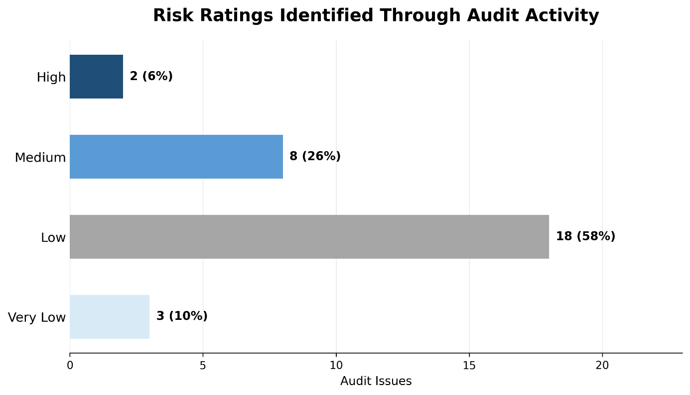

The total number of PMV issues raised in 2025–26 was 29. The risk ratings assigned to the issues are shown in Figure 2.

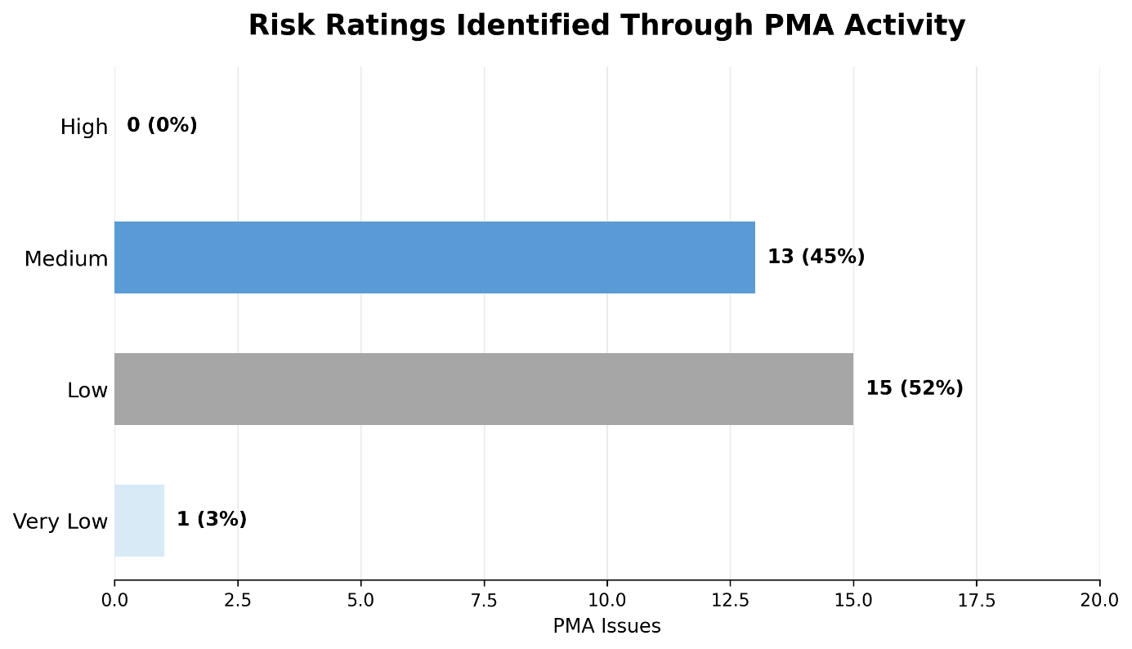
The total number of recommendations raised in 2025–26 was 38:
- 8 from awarding body audits
- 30 from provider monitoring activity
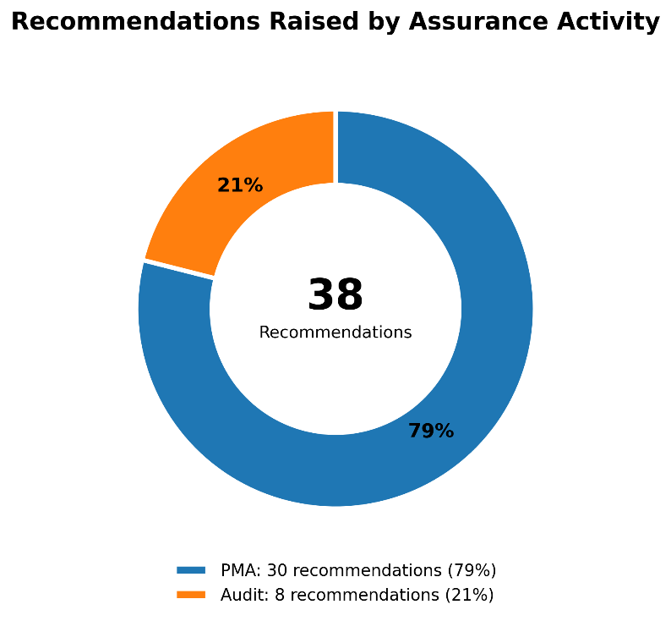

5.2 Themes of Issues and Recommendations raised

5.2.1 Audits
We have analysed the issues raised against awarding bodies during audits in 2025–26. The highest number of awarding body audit Issues were raised against Principles 7 and 9:
- Principle 7: The awarding body must have an effective approach for communicating with its staff, stakeholders and SQA Accreditation
- Principle 9: The awarding body and its providers must maintain accurate documents, records and data.
Note that one Issue can be assigned to more than one principle.
The recurring theme through 2025–26 audits has been the currency of documentation and incorrect terminology used. Also, a focus on awarding bodies deviating from formalised process.

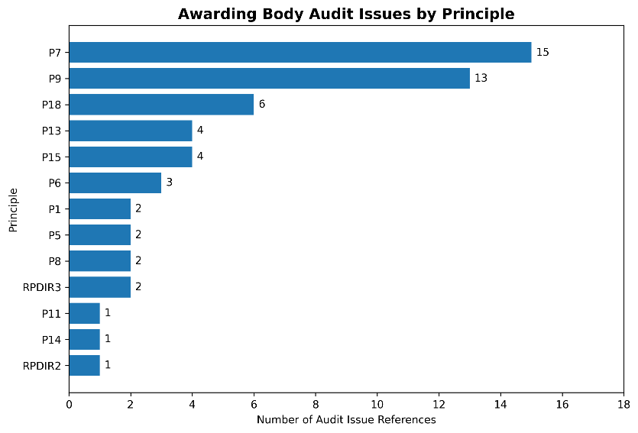
The greatest number of recommendations at audit were raised against Regulatory Principles 7 and 9
- Principle 9: The awarding body and its providers must maintain accurate documents, records and data.
- Principle 7: The awarding body must have an effective approach for communicating with its staff, stakeholders and Qualifications Scotland Accreditation

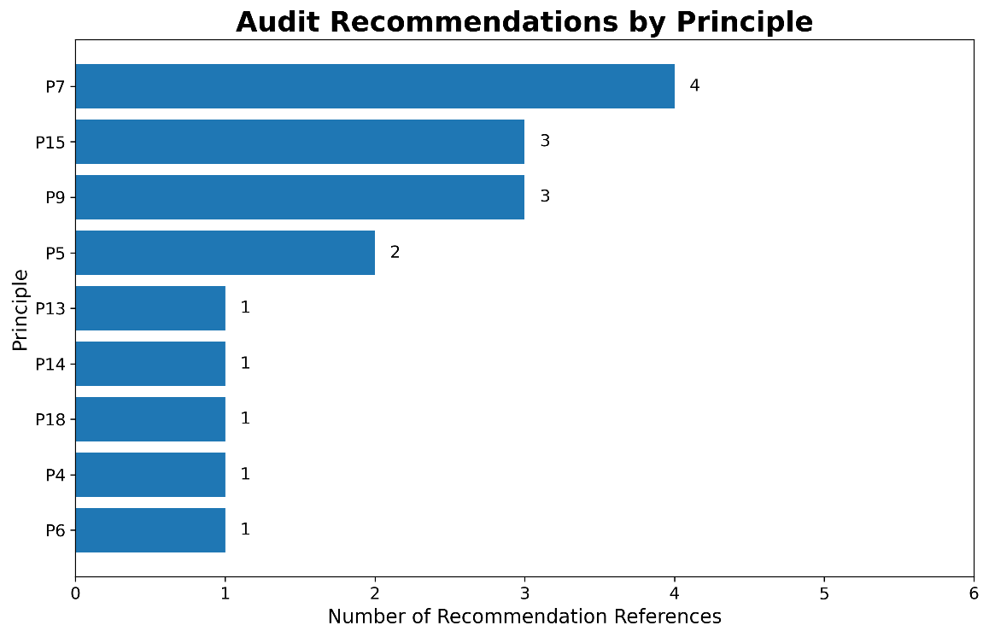

5.2.2 Provider monitoring activity
The highest number of Issues raised from provider monitoring activity was against Principles 9, and 18;
- Principle 9: The awarding body and its providers must maintain accurate documents, records and data.
- Principle 18: The awarding body and its providers must ensure that it has safeguards to prevent and manage cases of malpractice and maladministration.

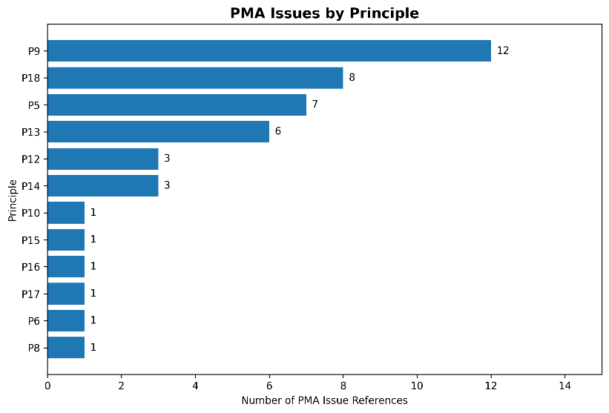

Common themes identified through Provider Monitoring Activity (PMA) predominantly related to documentation, policy implementation and provider oversight, rather than fundamental failures in qualification quality. The most frequently identified issues concerned malpractice and maladministration arrangements, with a number of awarding bodies and providers failing to clearly define both malpractice and maladministration, specify escalation requirements, or reflect current Qualifications Scotland Accreditation regulatory expectations for timely reporting. A second recurring theme was the use of outdated or inaccurate documentation, including obsolete legislative references, incorrect qualification titles, and inconsistent references to Qualifications Scotland Accreditation requirements across provider handbooks, approval documentation and quality assurance reports. Several findings also highlighted weaknesses in provider guidance and communication, where awarding bodies had not provided sufficiently clear, consistent or comprehensive instructions to providers or learners, including requirements relating to appeals processes, equality legislation, examination arrangements and centre responsibilities. Collectively, the PMA findings suggest that opportunities for improvement primarily relate to strengthening governance documentation, maintaining the accuracy and currency of policies and guidance, and ensuring providers have a clear understanding of their regulatory responsibilities and reporting obligations.
The greatest number of recommendations raised during provider monitoring activity were against Regulatory Principles 6, 5 and 7:
- Principle 6: The awarding body must continually review the effectiveness of its services, systems, policies and processes.
- Principle 5: The awarding body and its providers must provide clear information on their procedures, products and services and ensure that they are accurate and appropriate to accredited qualifications.
- Principle 7: The awarding body must have an effective approach for communicating with its staff, stakeholders and SQA Accreditation.
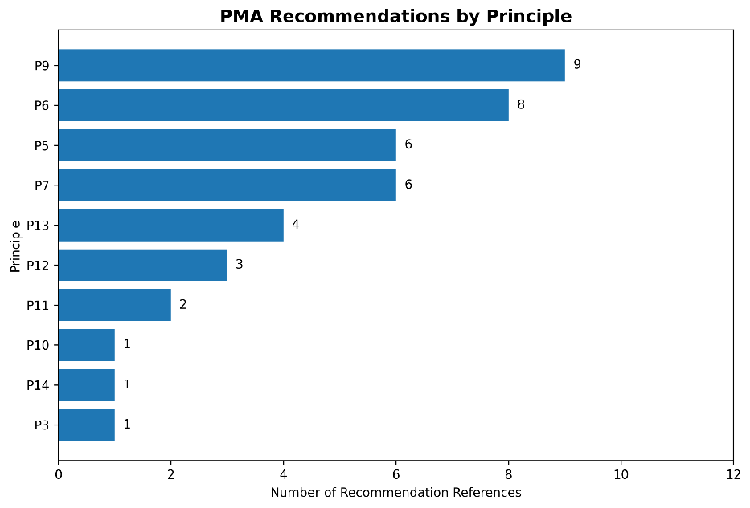

6 Chief Accreditation Officer: A look ahead to 2026-27

At the start of March, it was both an honour and a pleasure to join the team as Chief Accreditation Officer. Although at the time of writing this report I am still finding my feet, I am looking forward to getting started on helping to enable the team to deliver even better support next year. Since the implementation of the Education (Scotland) Act 2025 the independence of the Accreditation section has been strengthened through the new leadership structure, the new Convenor for the Accreditation Committee and the new Corporate Plan.
To this end, the main objective for the coming year is to consult on our Corporate Plan and then get started on the operational objectives that sit beneath. We will be meeting with our Awarding Bodies and their providers, with Standard Setting Organisations and Government, our regulatory colleagues in other nations and of course, with learners and practitioners. If you would like to be part of this consultation and we haven’t already been in touch, please email info.accreditation@qualifications.gov.scot. We greatly value your feedback and hope to be able to work with you to align ourselves with the appropriate priorities for Scotland.
We also want to raise wider awareness of the importance of accredited qualifications and what ‘sits behind’ our work. To this end we will be running a series of Webinars, commencing later this year, keep an eye on our newsletter for further information.
As we look to the future there are several projects on the horizon that aim to demonstrate the value of our accredited qualifications, such as continued work to ensure our processes and qualifications are accessible to all who wish to undertake them. Having now made the transition to Qualifications Scotland Accreditation, and with our new Accreditation Committee and Convenor in place we have a strong foundation for looking and moving forward.

Appendix: Qualifications Scotland Accreditation approved awarding bodies
Awarding body | Abbreviation (if used)
AIM Qualifications and Assessment | AIM
Alcohol Focus Scotland | AFS
Association of Accounting Technicians | AAT
Association of Chartered Certified Accountants | ACCA
Associated Sports Qualifications | ASQ
BIIAB Qualifications Limited | BIIAB
Chartered Institute of Housing | CIH
Chartered Management Institute | CMI
City & Guilds of London Institute | N/A
EduQual | N/A
EMPI Awards | N/A
Engineering Construction Industry Training Board | ECITB
Excellence, Achievement and Learning Limited | EAL
FireQual | N/A
First Aid Awards Limited | FAA
Future (Awards & Qualifications) Limited | FAQ
GQA Qualifications Limited | GQA
Highfield Qualifications | N/A
IMI Awards Limited | IMI
ITC First | ITC
Lantra Awards Limited | N/A
MP Awards | N/A
National Examination Board in Occupational Safety and Health | NEBOSH
PIABC Limited | N/A
Qualifications Scotland | N/A
RSL | N/A
Royal Academy of Dance | RAD
Safety Training Awards Limited | STA
SFEDI Awards | N/A
SFJ Awards | N/A
Smart Awards | N/A
The British Horse Society Qualifications | BHSQ
The King’s Trust | N/A
The Royal Environmental Health Institute of Scotland | REHIS
Vet Skill Limited | N/A
Vocational Training Charitable Trust | VTCT

