


Quarterly Statistics Report:
Highlights for Quarter 1 2026–27

August 2026

© Qualifications Scotland Accreditation 2026

Assuring Quality

Contents
Key Insights 2
1 Introduction 3
Methodology 3
2 Accredited qualifications 5
2.1 Total candidate registrations and certifications 6
2.2 Top 5 qualifications 6
2.3 Registrations and certifications by qualification type 7
2.3.1 SVQs 7
2.3.2 Non-SVQs 8
2.4 Analysis by awarding body 9
2.4.1 SVQs 9
2.4.2 Non-SVQs 10
2.5 Analysis by developer 10
2.6 Analysis by qualification categories 11
3 Workplace Core Skills 12

Key Insights
- In Q1 2026–27 the number of accredited qualifications has increased compared to Q1 2025–26. However the general trend indicates that the number of accredited qualifications is falling. Registrations remain strong which indicates that uptake is becoming more concentrated on fewer qualifications, and that qualifications are better aligned with industry and learner needs.
- The increase in uptake and year on year growth can mostly be attributed to non-SVQs, although uptake of SVQs has remained steady.
- The decrease in registrations (11.9%) this quarter in contrast to the increase in certifications (10.76%) suggests an increase in completion rates, or could indicate that learners registered in previous quarters completed during this period.
- The long-term trend shows a decline in the number of SVQs accredited which has been offset by the increase in the number of non-SVQs. This suggests that awarding bodies are streamlining their portfolios while ensuring current industry demand is met. This may also be symptomatic of the longer development and review cycles of the National Occupational Standards (NOS) associated with SVQ units and results in SVQs not being able to keep up with industry as fast as non-SVQs.
- Each quarter, around a third of registrations and certifications are attributed to the top 5 qualifications. This indicates that demand is highly concentrated within a limited number of occupationally relevant qualifications, especially within the first aid and social services sector. These courses are required for these sectors, and first aid courses are required to be repeated frequently.
- Almost half of all registrations (%) were in the Health Care, Social Care and Childcare sector, highlighting the continued importance of the qualifications in this regulated sector to ensure a high standard of care.

1 Introduction
Qualifications Scotland Accreditation is the national accrediting body for Scotland with a statutory remit under the Education (Scotland) Act 2025 to accredit and quality assure qualifications in Scotland. Although part of Qualifications Scotland, Qualifications Scotland Accreditation is distinct and autonomous from Qualifications Scotland’s awarding function.
Qualifications Scotland Accreditation sets and specifies the requirements for accrediting qualifications to safeguard and support the interests of learners, parents, funding bodies, employers, providers and Scottish Government. We do this to promote and maintain public confidence in accredited qualifications and approved awarding bodies.

Methodology
This report summarises the qualification data that has been provided to us by approved awarding bodies, referred to as ‘data submissions’. Awarding bodies use a data submission template so all submissions are standardised. Registration and certification data is provided directly to Qualifications Scotland Accreditation (further information on the methodology can be found in our Methodology document).
The information in this report covers our accredited qualifications during Q1 of 2026–27 (1 April 2026 to 30 June 2026) and shows the number of candidates who were:
- registered for a Qualifications Scotland Accreditation qualification
- certificated for a Qualifications Scotland Accreditation qualification
The data has been analysed in relation to:
- qualification type
- awarding body
- developer
- qualification category (classification)
- Workplace Core Skills
This document is published alongside the raw data received from the awarding bodies. If there are any figures below 10, these are removed to protect confidentiality and are represented by an asterisk (*). The numbers given do not necessarily represent the number of learners, as a learner could register for several qualifications and could have achieved several certifications. The statistical information in this report is only collated by Qualifications Scotland Accreditation.
For upcoming data submissions, the following deadline dates apply. All awarding bodies must adhere to these dates to ensure consistency and accuracy of data in future reports. Our guidance document clarifies how data must be submitted.
Table 1: Data submission deadlines for awarding bodies
Quarter | Submission deadline
Quarter 2 (1 July – 30 September 2026) | 14 October 2026
Quarter 3 (1 October – 30 December 2026) | 18 January 2027
Quarter 4 (1 January – 31 March 2027) | 14 April 2027
Quarter 1 (1 April – 30 June 2027) | 14 July 2027

2 Accredited qualifications
At the end of Q1 of 2026–27 there were 887 accredited qualifications*.
- 441 SVQs (49.72%)
- 446 Non-SVQs (50.28%)
*Note that this total does include qualifications that are within their lapsing period.
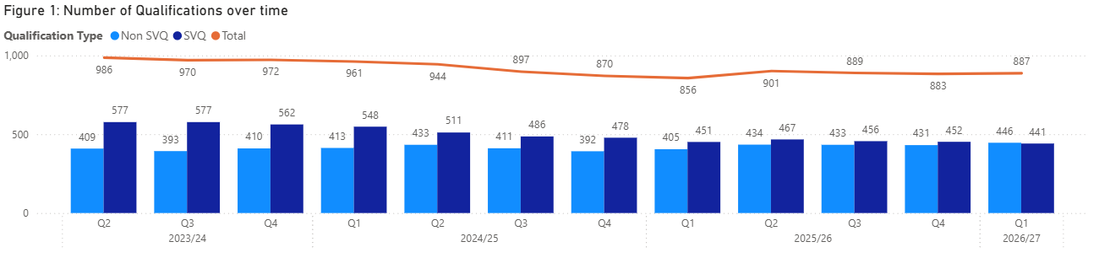
Compared to Q4 2025–26, the total number of qualifications submitted via data returns has increased by 4. In Q1 2025–26 there were 856 qualifications submitted. However the overall trend is a reduction in the number of qualifications submitted. This suggest that awarding bodies are rationalising their portfolios and responding to industry requirements.
For the first time, the number of non-SVQs is greater than the number of SVQs. The number of SVQs has decreased by 136 in the last three years, while non-SVQs have increased by 37. However, as shown in figure 2, uptake of qualifications has remained steady, strengthening the idea that awarding bodies are ensuring qualifications are keeping up with industry. This also may be in part due to our Zero Uptake Policy, which states that we can remove the accreditation of qualifications that have had no uptake for two years or more and the awarding body does not present clear evidence of demand. We produce a zero uptake report each year to highlight these qualifications, which aids our awarding bodies in streamlining their qualifications.
Non-SVQs are able to respond to changes much quicker than SVQs. As SVQ units have a one to one relationship with NOS and NOS reviews require funding and a thorough consultation process, they take longer to adapt. However SVQs are prized for their high standards and are trusted to ensure those who undertake them truly demonstrate the skills expected of the job role.

2.1 Total candidate registrations and certifications
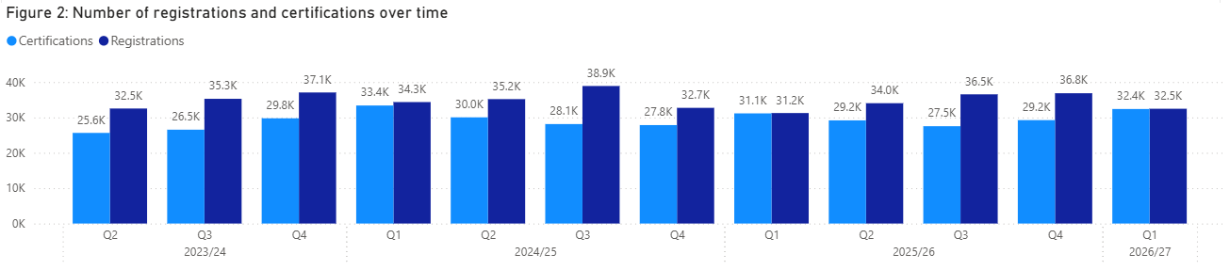
32,461 candidates were registered for Qualifications Scotland Accreditation qualifications in Q1. This is a decrease of 11.9% compared to Q4 2025–26.
32,389 certificates were awarded for Qualifications Scotland Accreditation qualifications in Q4. This is an increase of 10.76% compared to Q4 2025–26.

2.2 Top 5 qualifications
Table 2: Top 5 qualifications by registration
Qualification title | Registrations | Awarding body
Award in Emergency First Aid at Work at SCQF Level 6 | 5564 | First Aid Awards Limited (FAA)
NEBOSH National General Certificate in Occupational Health and Safety | 3213 | NEBOSH
SVQ in Social Services and Healthcare at SCQF level 6 | 1097 | Qualifications Scotland
Award in First Aid for Mental Health at SCQF Level 5 | 1082 | FAA
SVQ in Social Services and Healthcare at SCQF level 7 | 1006 | Qualifications Scotland
Total | 11,962

The Award in Emergency First Aid at Work at SCQF Level 6 (FAA) had the highest number of registrations in Q1 of 2026–27. These top 5 qualifications account for 36.85% of all registrations in Q1. They are consistently within the Health Care, Social Care, Childcare and first aid sectors demonstrating the value and requirement of these qualifications within these highly regulated sectors.

Table 3: Top 5 qualifications by certification
Qualification title | Certifications | Awarding body
Award in Emergency First Aid at Work at SCQF Level 6 | 5455 | FAA
NEBOSH National General Certificate in Occupational Health and Safety | 1649 | NEBOSH
SVQ in Social Services and Healthcare at SCQF level 6 | 1096 | Qualifications Scotland
Award in First Aid for Mental Health at SCQF level 5 | 1080 | FAA
Award in Emergency First Aid at Work at SCQF level 6 | 976 | Qualifications Scotland
Total | 10,256

The Award in Emergency First Aid at Work at SCQF Level 6 (FAA) had the highest number of certifications in Q1 of 2026–27. These top 5 qualifications account for 31.67% of all certifications in Q1. The certifications reflect the registrations, in that they are also all within the same sectors.

2.3 Registrations and certifications by qualification type
The following figures detail the number of registrations and certifications over a three-year period, broken down by qualification type. As there are peaks and troughs throughout the year for SVQs (SVQs peak during Q2 and Q3), it is more appropriate to compare the number of registrations and certifications to the equivalent quarter from the previous year than to the preceding quarter.
As evidenced in the graphs below, the number of registrations and certifications for non-SVQs has risen over time and is much higher than that of SVQs. However, non-SVQs often consist of short courses, such as 1-day first aid courses, whereas SVQs can be more extensive and can take up to 4 years depending on the SCQF level, hence the pattern of registrations and certifications.

2.3.1 SVQs
- 6041 registrations
- 7746 certifications
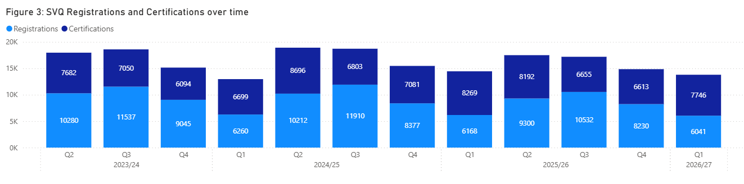
In comparison to Q1 of 2025–26:
- The number of SVQ registrations has decreased by 2.06%.
- The number of SVQ certifications has decreased by 6.32%.

These figures demonstrate the pattern of uptake over the academic year. As the qualifications finish in quarter 1 (April to June), this is when certifications would be highest, but registrations would be low. This is consistent with previous years.

2.3.2 Non-SVQs
- 26,420 registrations
- 24,643 certifications
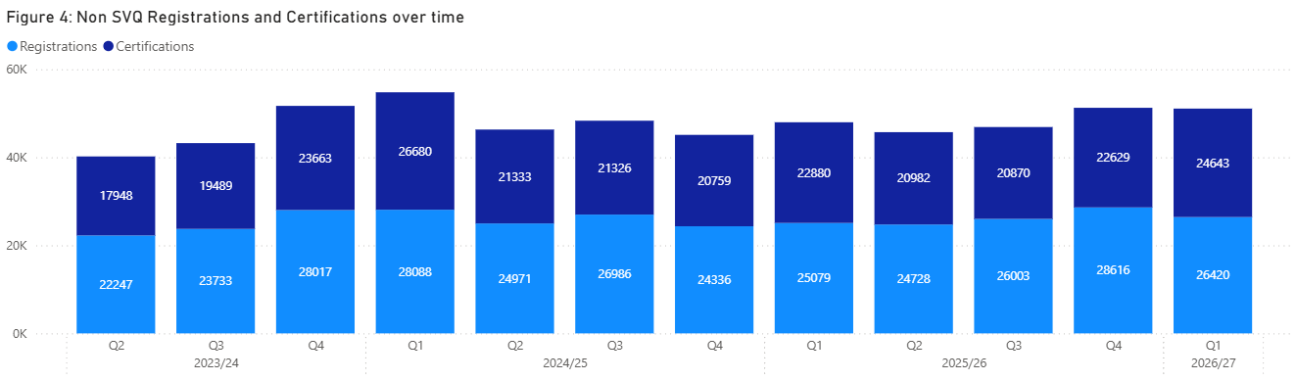
In comparison to Q4 of 2025–26:
- The number of non-SVQ registrations has decreased by 7.67%.
- The number of non-SVQ certifications has increased by 8.90%.
There is no clear trend demonstrated through the non-SVQ uptake data. These qualifications can be taken throughout the year and often take less time to complete compared to SVQs.

2.4 Analysis by awarding body
At the end of the first quarter, there were 34 awarding bodies approved by Qualifications Scotland Accreditation. The number of qualifications offered by each awarding body varies greatly. The five largest awarding bodies, in terms of qualifications offered (including lapsed), are shown in table 4.
Table 4: Top 5 awarding bodies by qualifications
Awarding body | Qualifications
Qualifications Scotland | 339
RSL Awards Ltd | 58
Institute of the Motor Industry | 53
Royal Academy of Dance | 33
FireQual Ltd | 30
Total | 513

2.4.1 SVQs
Qualifications Scotland continues to have the highest number of SVQ registrations and certifications:
- 82.02% of SVQ registrations
- 78.92% of SVQ certifications
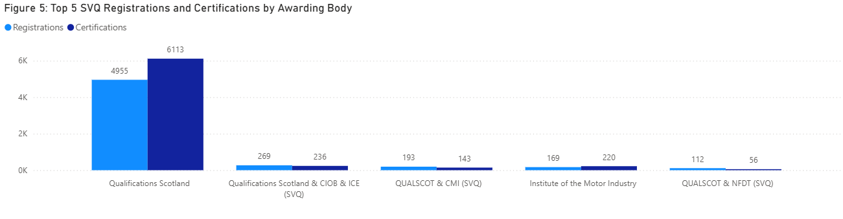
This shows that SVQ activity is dominated by one awarding body and reflects Qualifications Scotland’s role in areas where SVQs are the recognised qualifications, such as Health Care, Social Care and Child Care, as these are required by professional bodies such as the Scottish Social Services Council (SSSC).

2.4.2 Non-SVQs
First Aid Awarding (FAA) accounted for the highest number of non-SVQ registrations and certifications:
- 33.81% of registrations
- 35.73% of certifications
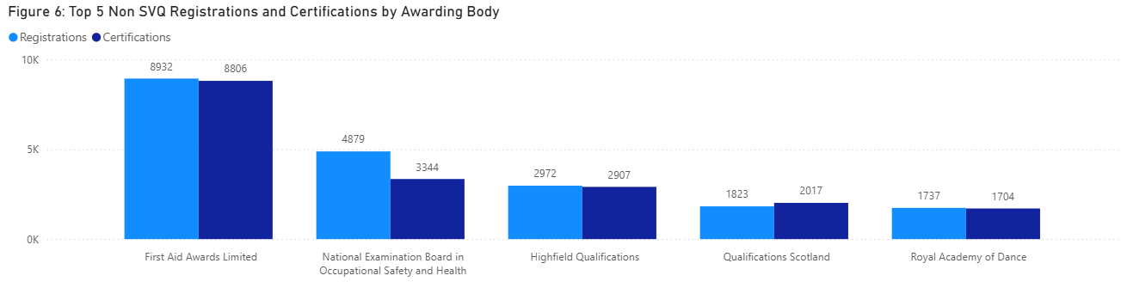
These figures also relate to the Health Care, Social Care and Child Care sectors as they require that first aid training is up to date and therefore must be repeated frequently (usually every three years).

2.5 Analysis by developer
This section compares the registrations and certifications by developer across the two qualification types — SVQs and non-SVQs. The following graph summarises the top registrations and certifications by developer.
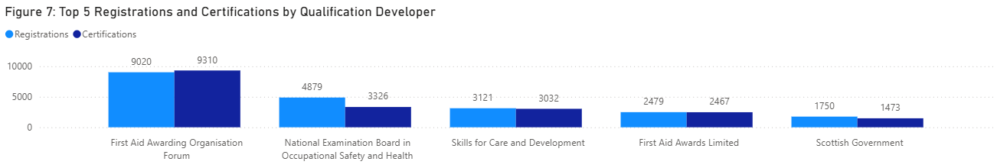
First Aid Awarding Organisation Forum (FAAOF) has the highest number of registrations (34.14%) and certifications (37.78%), again highlighting the dominance of the Care sector within our qualifications.
This is reflected through both SVQs and non-SVQs:
- Skills for Care and Development accounts for the largest proportion of SVQ registrations and certifications — 51.67% and 39.14%, respectively.
- For non-SVQ qualifications, First Aid Awarding Organisation Forum (FAAOF) has the highest number of registrations (34.14%) and certifications (37.78%).

2.6 Analysis by qualification categories
Qualifications Scotland Accreditation assigns qualifications to one of the following 16 qualification categories:
- 001 Land-based and Aquaculture
- 002 Business Administration
- 003 Health Care, Social Care and Childcare
- 004 Protective Services
- 005 Catering, Hospitality and Tourism
- 006 Construction
- 007 Creative and Design
- 008 IT and Digital
- 009 Education and Training
- 010 Engineering and Manufacturing
- 011 Hair and Beauty
- 012 Science and Mathematics
- 013 Retail
- 014 Legal and Financial
- 015 Sports and Active Leisure
- 016 Transport and Logistics
Table 5: Top 5 SVQ registrations and certifications by category
Qualification category | Registrations | Certifications
003 Health Care, Social Care and Childcare | 3116 | 3374
006 Construction | 1458 | 2016
010 Engineering and Manufacturing | 466 | 918
002 Business Administration | 361 | 389
005 Catering Hospitality and Tourism | 134 | 298
Total | 5735 | 6995

The area with the highest number of SVQ registrations and certifications is 003 Health Care, Social Care and Childcare. This is followed by Construction, then Engineering and Manufacturing. Engineering and Manufacturing has the highest number of accredited qualifications, closely followed by Construction. These areas are also regulated and require specialised knowledge. There is high turnover in all three of these sectors, so the number of learners completing these qualifications does not necessarily reflect the number of those in the workforce.
Table 6: Top 5 non-SVQ registrations and certifications by category
Qualification category | Registrations | Certifications
003 Health Care, Social Care and Childcare | 12860 | 13062
004 Protective Services | 8321 | 6749
015 Sports and Active Leisure | 1748 | 1725
009 Education and Training | 913 | 553
014 Legal and Financial | 893 | 227
Total | 24735 | 22316

More than half of all non-SVQ registrations and certifications are within Health Care, Social Care and Childcare, showing the large demand for a skilled workforce.
The top 5 sectors within non-SVQs are more volatile, changing frequently, with the exception of Health Care, Social Care and Childcare. This may demonstrate seasonal changes, such as the rise of Sports and Active Leisure.

3 Workplace Core Skills
Workplace Core Skills are the broad, transferable skills that help to develop the main capabilities people need to be full, active and responsible members of society. Workplace Core Skills were specifically developed to assess Core Skills in a work environment. They contribute to employability and are a component of Modern Apprenticeships in Scotland. Each Workplace Core Skill is available at SCQF levels 3 to 6.
The five Workplace Core Skills are:
- Communication
- Information and Communication Technology (ICT)
- Numeracy
- Problem Solving
- Working with Others
At the end of Q1 2026–27, there were:
- 75 live accredited Workplace Core Skills
- 5672 registrations (a decrease of 16.74% compared to Q4 2025–26)
- 5870 certifications (an increase of 3.49% compared to Q4 2025–26)
Workplace Core Skills were offered by five awarding bodies. However City & Guilds Workplace Core Skills are now in their lapsing period.
Table 7: Workplace Core Skills registrations and certifications by awarding body
Awarding body | Registrations | Certifications
Qualifications Scotland | 5082 | 5218
Institute of the Motor Industry (IMI) | 545 | 448
City & Guilds** | 0 | 80
Excellence, Achievement & Learning Ltd (EAL) | 41 | 113
Vocational Training Charitable Trust (VTCT) | * | 11
Total | 5672 | 5870

**City & Guilds registers candidates for Workplace Core Skills on a one-to-many basis using their internal Programme of Study number (PoS), therefore it is not possible at this time to generate registration figures for each Core Skill.
*Any number less than 10 and greater than 0 is redacted to ensure anonymity of learners.

