
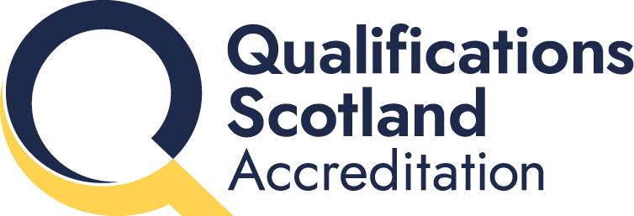

Quarterly Statistics Report:
Highlights for Quarter 3 2025–26

1 May 2026

© Qualifications Scotland Accreditation 2026

Assuring Quality

Contents
Summary 2
Data submissions 2
SVQs 3
Non-SVQ qualifications 3
Qualification category 3
Workplace Core Skills 3
1 Introduction 4
Methodology 4
2 Accredited qualifications 6
2.1 Total candidate registrations and certifications 7
2.2 Top 5 qualifications 7
2.3 Registrations and certifications by qualification type 8
2.3.1 SVQs 8
2.3.2 Non-SVQs 9
2.4 Analysis by awarding body 10
2.4.1 SVQs 10
2.4.2 Non-SVQs 11
2.5 Analysis by developer 11
2.5.1 SVQs 11
2.5.2 Non-SVQs 12
2.6 Analysis by qualification categories 13
3 Workplace Core Skills 14

Summary
From 1 February 2026, Qualifications Scotland Accreditation became fully operational, replacing Scottish Qualifications Authority (SQA) Accreditation. This report references SQA Accreditation as it concerns the third quarter (Q3) of 2025–26. All following reports will refer to Qualifications Scotland Accreditation.
This report provides statistical information on SQA Accreditation approved qualifications for Q3 of 2025–26 (1 October 2025 to 31 December 2025). This data is submitted by awarding bodies, who are responsible for quality assuring their data submissions.
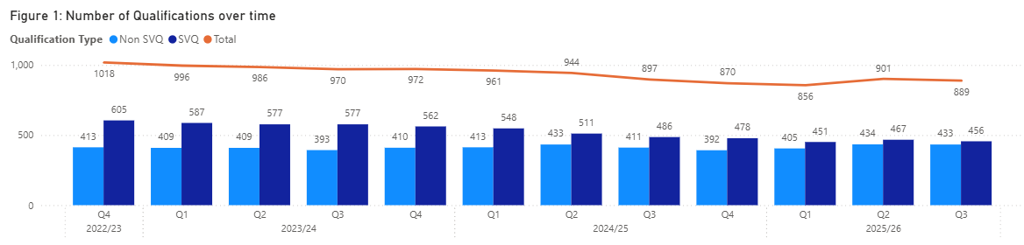
At the end of this period there were 889 accredited qualifications: 456 Scottish Vocational Qualifications (SVQs), and 433 Non-SVQs. In Q3 2024–25 there were 897 accredited qualifications, compared to 970 in Q3 of 2023–24.

Data submissions
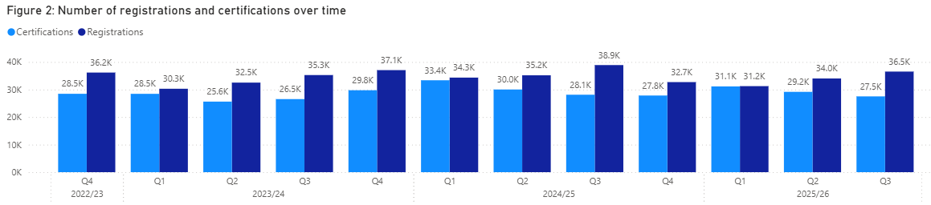
There were a total of 36,535 registrations (a 7.37% increase from Q2 2025–26) and 27,525 certifications (a 5.65% decrease compared to Q2 2025–26) in Q3. (These totals do not include Workplace Core Skills.)

SVQs
Of these totals, 10,532 (28.83%) were SVQ registrations and 6655 (24.18%) were SVQ certifications. SQA was the awarding body that had the highest percentage of SVQ registrations (76.46%) and certifications (72.76%). The developer Skills for Care and Development accounts for the largest proportion of SVQ registrations and certifications — 37% and 41.01%, respectively.

Non-SVQ qualifications
There were 26,003 registrations and 20,870 certifications, a decrease of 3.64% and 2.14% respectively compared to Q3 2024–25. First Aid Awarding (FAA) accounted for the highest number of Non-SVQ registrations and certifications: 37.44% of registrations, 46.18% of certifications. The developer First Aid Awarding Organisation Forum (FAAOF) had the highest number of registrations (40.33%) and certifications (49.23%).

Qualification category
The area with the highest number of registrations and certifications for SVQs was 003 Health Care, Social Care and Childcare.

Workplace Core Skills
There were a total of 7741 registrations (an increase of 28.59% compared to Q2) and 5436 certifications (a decrease of 18.47% compared to Q2).

1 Introduction
SQA Accreditation is the national accrediting body for Scotland with a statutory remit under the Education (Scotland) Act 1996 to accredit and quality assure qualifications in Scotland. Although part of the SQA, SQA Accreditation is distinct and autonomous from SQA’s awarding function.
SQA Accreditation sets and specifies the requirements for accrediting qualifications to safeguard and support the interests of learners, parents, funding bodies, employers, providers and Scottish Government. We do this to promote and maintain public confidence in accredited qualifications and approved awarding bodies.

Methodology
This report summarises the qualification data that has been provided to us by approved awarding bodies, referred to as ‘data submissions’. Awarding bodies use a data submission template so all submissions are standardised. Registration and certification data is provided directly to SQA Accreditation (further information on the methodology can be found in our Methodology document).
The information in this report covers SQA accredited qualifications during Q3 of 2025–26 (1 October 2025 to 31 December 2025) and shows the number of candidates who were:
- registered for an SQA accredited qualification
- certificated for an SQA accredited qualification
The data has been analysed in relation to:
- qualification type
- awarding body
- developer
- qualification category (classification)
- Workplace Core Skills
This document is published alongside the raw data received from the awarding bodies. If there are any figures below 10, these are removed to protect confidentiality and are represented by an asterisk (*). The numbers given do not necessarily represent the number of learners, as a learner could register for several qualifications and could have achieved several certifications. The statistical information in this report is only collated by SQA Accreditation.
For upcoming data submissions, the following deadline dates apply. All awarding bodies must adhere to these dates to ensure consistency and accuracy of data in future reports. Our guidance document clarifies how data must be submitted.
Table 1: Data submission deadlines for awarding bodies
Quarter | Submission deadline
Quarter 4 (1 January – 31 March 2026) | 16 April 2026
Quarter 1 (1 April – 30 June 2026) | 14 July 2026
Quarter 2 (1 July – 30 September 2026) | 14 October 2026
Quarter 3 (1 October – 30 December 2026) | 18 January 2027

2 Accredited qualifications
At the end of Q3 of 2025–26 there were 889 accredited qualifications*.
- 456 SVQs (51.29%)
- 433 Non-SVQs (48.71%)
* Note that this total does include qualifications that are within their lapsing period.
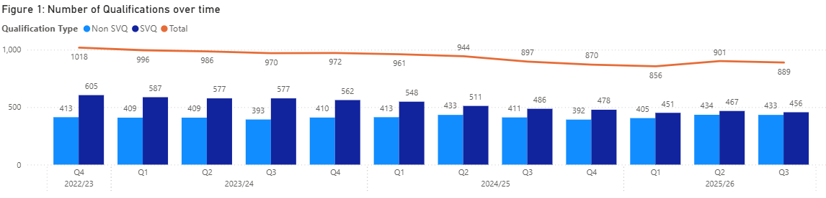
Compared to Q2 2025–26, the total number of qualifications submitted via data returns has decreased by 12. In Q3 2024–25 there were 897 qualifications submitted.
The number of qualifications has remained steady overall. The number of SVQs has decreased by 149 in the last three years, while Non-SVQs have remained steady, meaning the percentage difference between the two has decreased.
In our SVQ research we found that our stakeholders felt SVQs were less flexible, despite being supportive of the one to one relationship with National Occupational Standards (NOS). SVQs were found to be slower to adapt than Non-SVQ counterparts. There is also a growing number of Non-SVQs available through Modern Apprenticeships. As seen below, the number of registrations and certifications for Non-SVQs has always been significantly higher than for SVQs, despite there being fewer qualifications. However SVQs are often more extensive with more units to complete.

2.1 Total candidate registrations and certifications
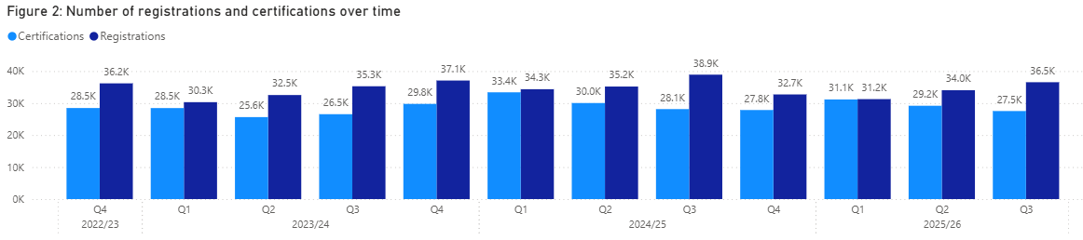
36,535 candidates were registered for SQA accredited qualifications in Q3. This is an increase of 7.37% compared to Q2 2025–26.
27,525 certificates were awarded for SQA accredited qualifications in Q3. This is a decrease of 5.65% compared to Q2 2025–26.

2.2 Top 5 qualifications
Table 2: Top 5 qualifications by registration
Qualification title | Registrations | Awarding body
Award in Emergency First Aid at Work at SCQF Level 6 | 6805 | First Aid Awards Limited (FAA)
NEBOSH National General Certificate in Occupational Health and Safety | 2884 | NEBOSH
SVQ in Social Services and Healthcare at SCQF level 6 | 1269 | SQA
SVQ in Social Services and Healthcare at SCQF level 7 | 1098 | SQA
SVQ in Social Services (Children and Young People) at SCQF level 7 | 937 | SQA
Total | 12,993

The Award in Emergency First Aid at Work at SCQF Level 6 (FAA) had the highest number of registrations in Q3 of 2025–26. These top 5 qualifications account for 35.56% of all registrations in Q3.

Table 3: Top 5 qualifications by certification
Qualification title | Certifications | Awarding body
Award in Emergency First Aid at Work at SCQF Level 6 | 6717 | FAA
NEBOSH National General Certificate in Occupational Health and Safety | 1923 | NEBOSH
SVQ in Social Services and Healthcare at SCQF level 6 | 947 | SQA
Highfield Award in Emergency First Aid at Work at SCQF Level 6 | 869 | Highfield
SVQ in Social Services and Healthcare at SCQF level 7 | 822 | SQA
Total | 11,278

The Award in Emergency First Aid at Work at SCQF Level 6 (FAA) had the highest number of certifications in Q3 of 2025–26. These top 5 qualifications account for 40.97% of all certifications in Q3.

2.3 Registrations and certifications by qualification type
The following figures detail the number of registrations and certifications over a three-year period, broken down by qualification type. As there are peaks and troughs throughout the year for SVQs (SVQs peak during Q2 and Q3), it is more appropriate to compare the number of registrations and certifications to the equivalent quarter from the previous year than to the preceding quarter.
As evidenced in the graphs below, the number of registrations and certifications for Non-SVQs has risen over time and is much higher than that of SVQs. However, Non-SVQs often consist of shorted courses, such as 1-day first aid courses, whereas SVQs can be more extensive.

2.3.1 SVQs
- 10,532 registrations
- 6655 certifications
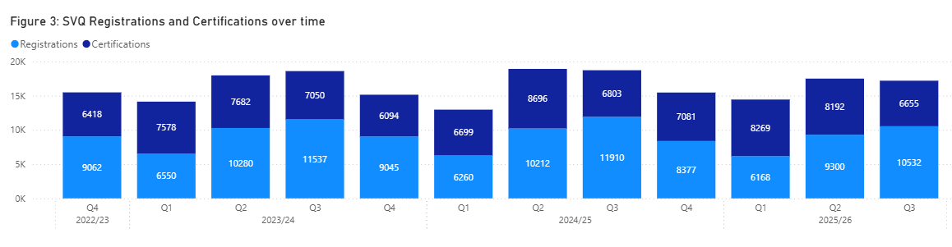
In comparison to Q3 of 2024–25:
- The number of SVQ registrations has decreased by 11.57%.
- The number of SVQ certifications has decreased by 2.17%.

2.3.2 Non-SVQs
- 26,003 registrations
- 20,870 certifications
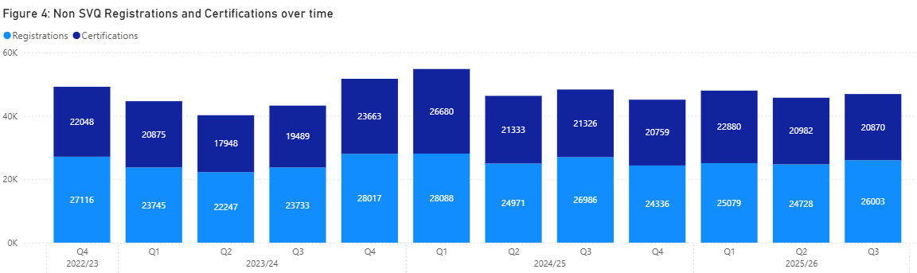
In comparison to Q3 of 2024–25:
- Non-SVQ registrations are 3.64% lower in Q3 2025–26.
- Non-SVQ certifications are 2.14% lower in Q3 2025–26.

2.4 Analysis by awarding body
At the end of the third quarter, there were 35 awarding bodies approved by SQA Accreditation. The number of qualifications offered by each awarding body varies greatly. The five largest awarding bodies, in terms of qualifications offered (including lapsed), are shown in table 4.
Table 4: Top 5 awarding bodies by qualifications
Awarding body | Qualifications
SQA | 326
RSL Awards Ltd | 66
Institute of the Motor Industry | 53
Royal Academy of Dance | 33
FireQual Ltd | 29
Total | 507

2.4.1 SVQs
SQA continues to have the highest number of SVQ registrations and certifications:
- 76.46 % of SVQ registrations
- 72.76 % of SVQ certifications
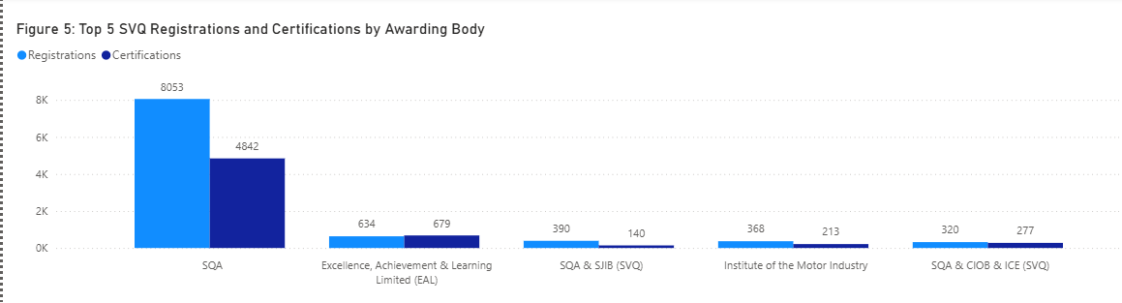

2.4.2 Non-SVQs
First Aid Awarding (FAA) accounted for the highest number of Non-SVQ registrations and certifications:
- 37.44% of registrations
- 46.18% of certifications
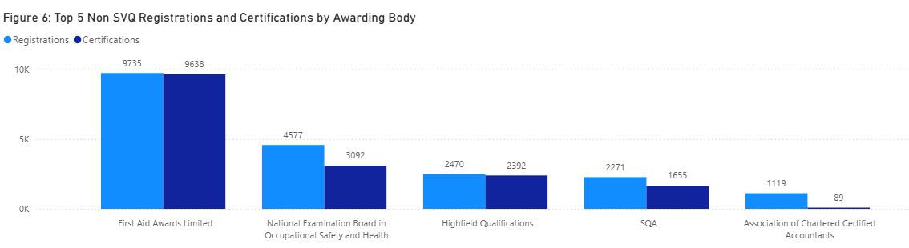

2.5 Analysis by developer
This section compares the registrations and certifications by developer across the two qualification types — SVQs and Non-SVQs. The following graph summarises the top registrations and certifications by developer.
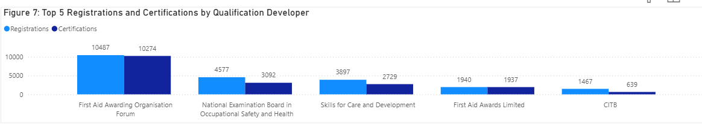
First Aid Awarding Organisation Forum (FAAOF) has the highest number of registrations (28.70%) and certifications (37.33%).

2.5.1 SVQs
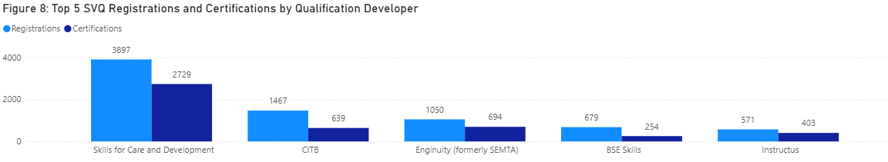
Skills for Care and Development accounts for the largest proportion of SVQ registrations and certifications — 37% and 41.01%, respectively.

2.5.2 Non-SVQs
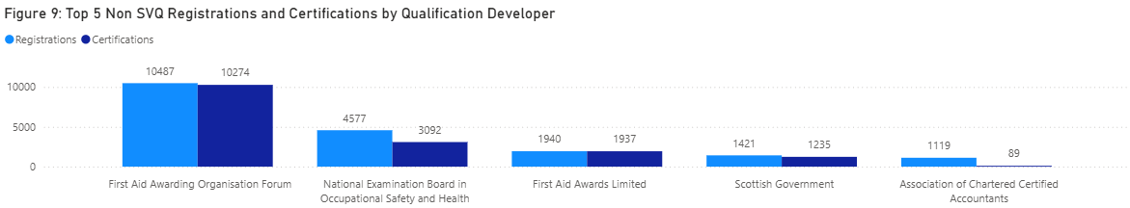
For Non-SVQ qualifications, First Aid Awarding Organisation Forum (FAAOF) has the highest number of registrations (40.32%) and certifications (49.23%).

2.6 Analysis by qualification categories
SQA Accreditation assigns qualifications to one of the following 16 qualification categories:
- 001 Land-based and Aquaculture
- 002 Business Administration
- 003 Health care, Social care and Childcare
- 004 Protective Services
- 005 Catering, Hospitality and Tourism
- 006 Construction
- 007 Creative and Design
- 008 IT and Digital
- 009 Education and Training
- 010 Engineering and Manufacturing
- 011 Hair and Beauty
- 012 Science and Mathematics
- 013 Retail
- 014 Legal and Financial
- 015 Sports and Active Leisure
- 016 Transport and Logistics
Table 5: Top 5 SVQ registrations and certifications by category
Qualification category | Registrations | Certifications
003 Health Care, Social Care and Childcare | 4257 | 2986
006 Construction | 2540 | 1435
010 Engineering and Manufacturing | 1666 | 998
002 Business Administration | 573 | 434
005 Catering Hospitality and Tourism | 541 | 328
Total | 9577 | 6181

The area with the highest number of SVQ registrations and certifications is 003 Health Care, Social Care and Childcare.
- 40.42% of registrations
- 44.87% of certifications
Anyone entering into a job in the health and social care sector in Scotland must register with the Scottish Social Services Council (SSSC) and obtain the appropriate qualification, hence the consistently high number of registrations in this sector. As seen below, there are also Non-SVQ qualifications approved by the SSSC.
Table 6: Top 5 Non-SVQ registrations and certifications by category
Qualification category | Registrations | Certifications
003 Health Care, Social Care and Childcare | 13544 | 13162
004 Protective Services | 7199 | 5435
010 Engineering and Manufacturing | 1393 | 222
014 Legal and Financial | 1245 | 240
015 Sports and Active Leisure | 718 | 769
Total | 24099 | 19828

The area with the highest number of Non-SVQ registrations and certifications is 003 Health Care, Social Care and Childcare.
- 52.08% of registrations
- 63.06% of certifications

3 Workplace Core Skills
Workplace Core Skills are the broad, transferable skills that help to develop the main capabilities people need to be full, active and responsible members of society. Workplace Core Skills were specifically developed to assess Core Skills in a work environment. They contribute to employability and are a component of Modern Apprenticeships in Scotland. Each Workplace Core Skill is available at SCQF levels 3 to 6.
The five Workplace Core Skills are:
- Communication
- Information and Communication Technology (ICT)
- Numeracy
- Problem Solving
- Working with Others
At the end of Q3 2025–26, there were:
- 95 live accredited Workplace Core Skills
- 7741 registrations (an increase of 28.58% compared to Q2 2025–26)
- 5436 certifications (a decrease of 18.47% compared to Q2 2025–26)
Workplace Core Skills were offered by five awarding bodies.
Table 7: Workplace core skills registrations and certifications by awarding body
Awarding body | Registrations | Certifications
SQA | 6433 | 4869
Institute of the Motor Industry (IMI) | 1088 | 354
City & Guilds | 0 | 115
Excellence, Achievement & Learning Ltd (EAL) | 203 | 76
Vocational Training Charitable Trust (VTCT) | 17 | 22
Total | 7741 | 5436

*City & Guilds registers candidates for Workplace Core Skills on a one-to-many basis using their internal Programme of Study number (PoS), therefore it is not possible at this time to generate registration figures for each Core Skill.
SQA continues to have the highest registrations and certifications for Workplace Core Skills:
- 83.10% of registrations
- 89.56% of certifications

